Phase-End Project 3

Non-Functional Testing Using Postman, REST Assured, and JMeter

Project Agenda: To automate functionalities using https://petstore.swagger.io/ REST API services

Scenario:

You are working as a Test Engineer in XYZ Corp. Your company has decided to automate a few functionalities for one of the Pet Store companies.

You have been asked to design an end-to-end functionality to automate three REST API services using Postman and Rest Assured.

Tools Required:

● Postman

● Java 1.8+

● Maven

● Rest Assured Maven dependency version 4.5.1

● TestNG Maven dependency version 7.1.0

● Hamcrest Maven dependency

● Newman for Postman

● JMeter

Postman Assignment_001:

🡺Create petID and PetName:

● Create a CSV file with two columns, petID and petName, having 20 rows’ details as below example

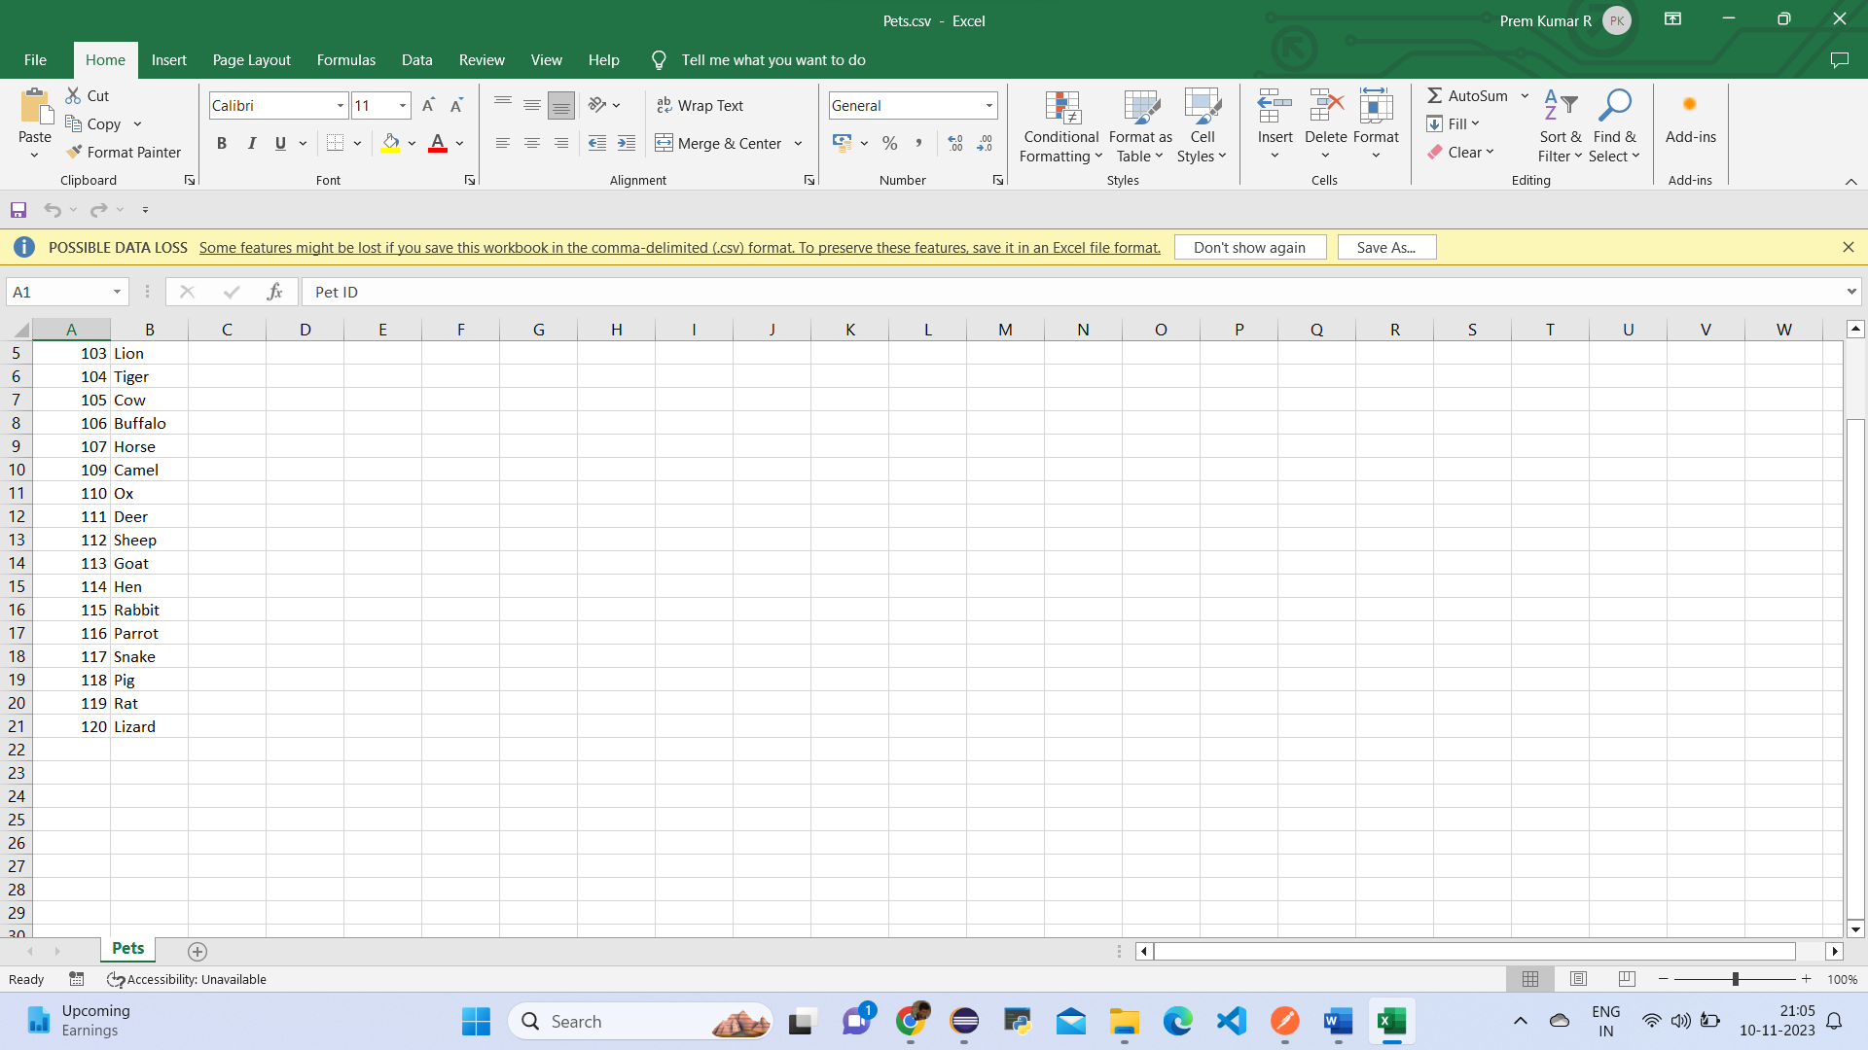

Open Postman

● Create a new collection called Pet_ID_Testing and arrange three end-to-end services as shown below:

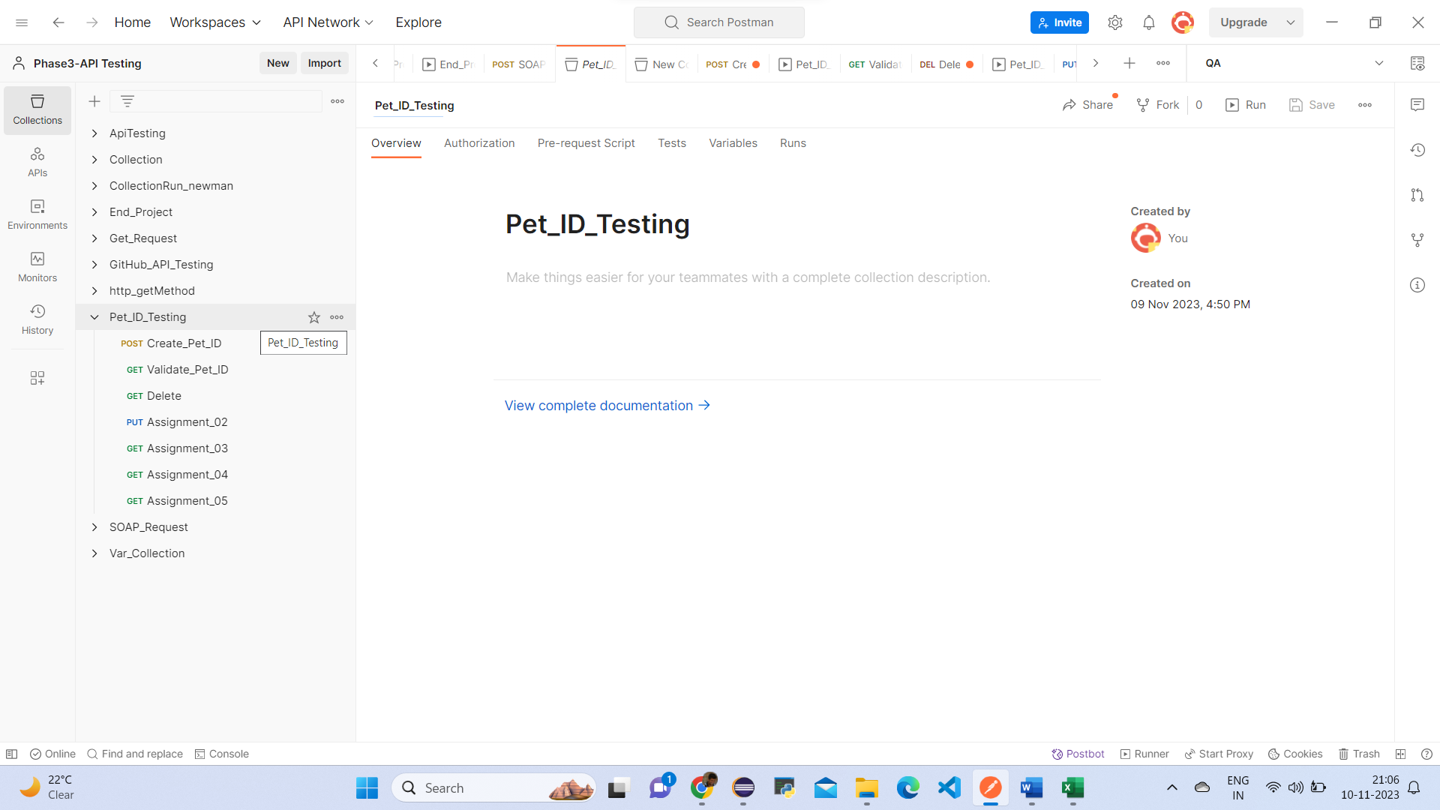

In the collection, add a new POST service request with following details:

* ○ URL: <https://petstore.swagger.io/v2/pet>
* ○ Service Type: POST
* ○ JSON Body

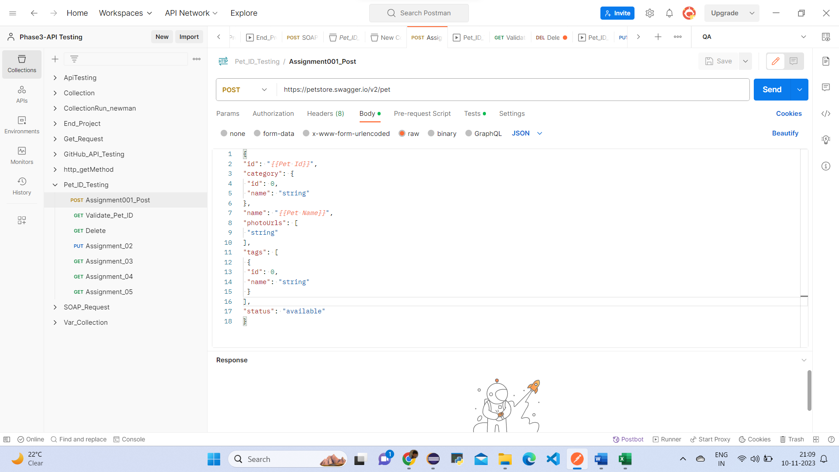

Create the Environment

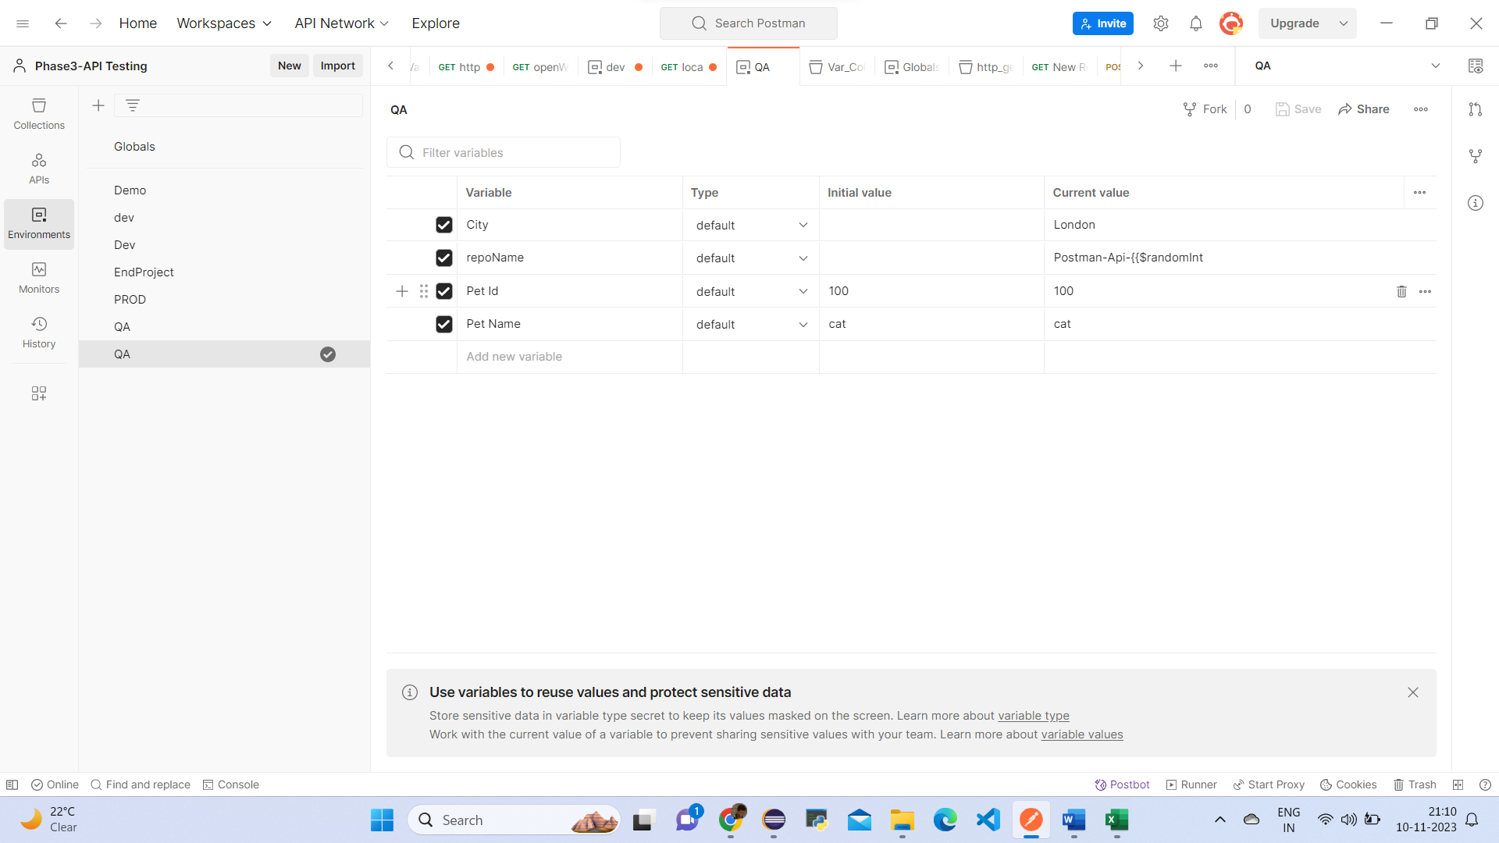

Write Some of the tests

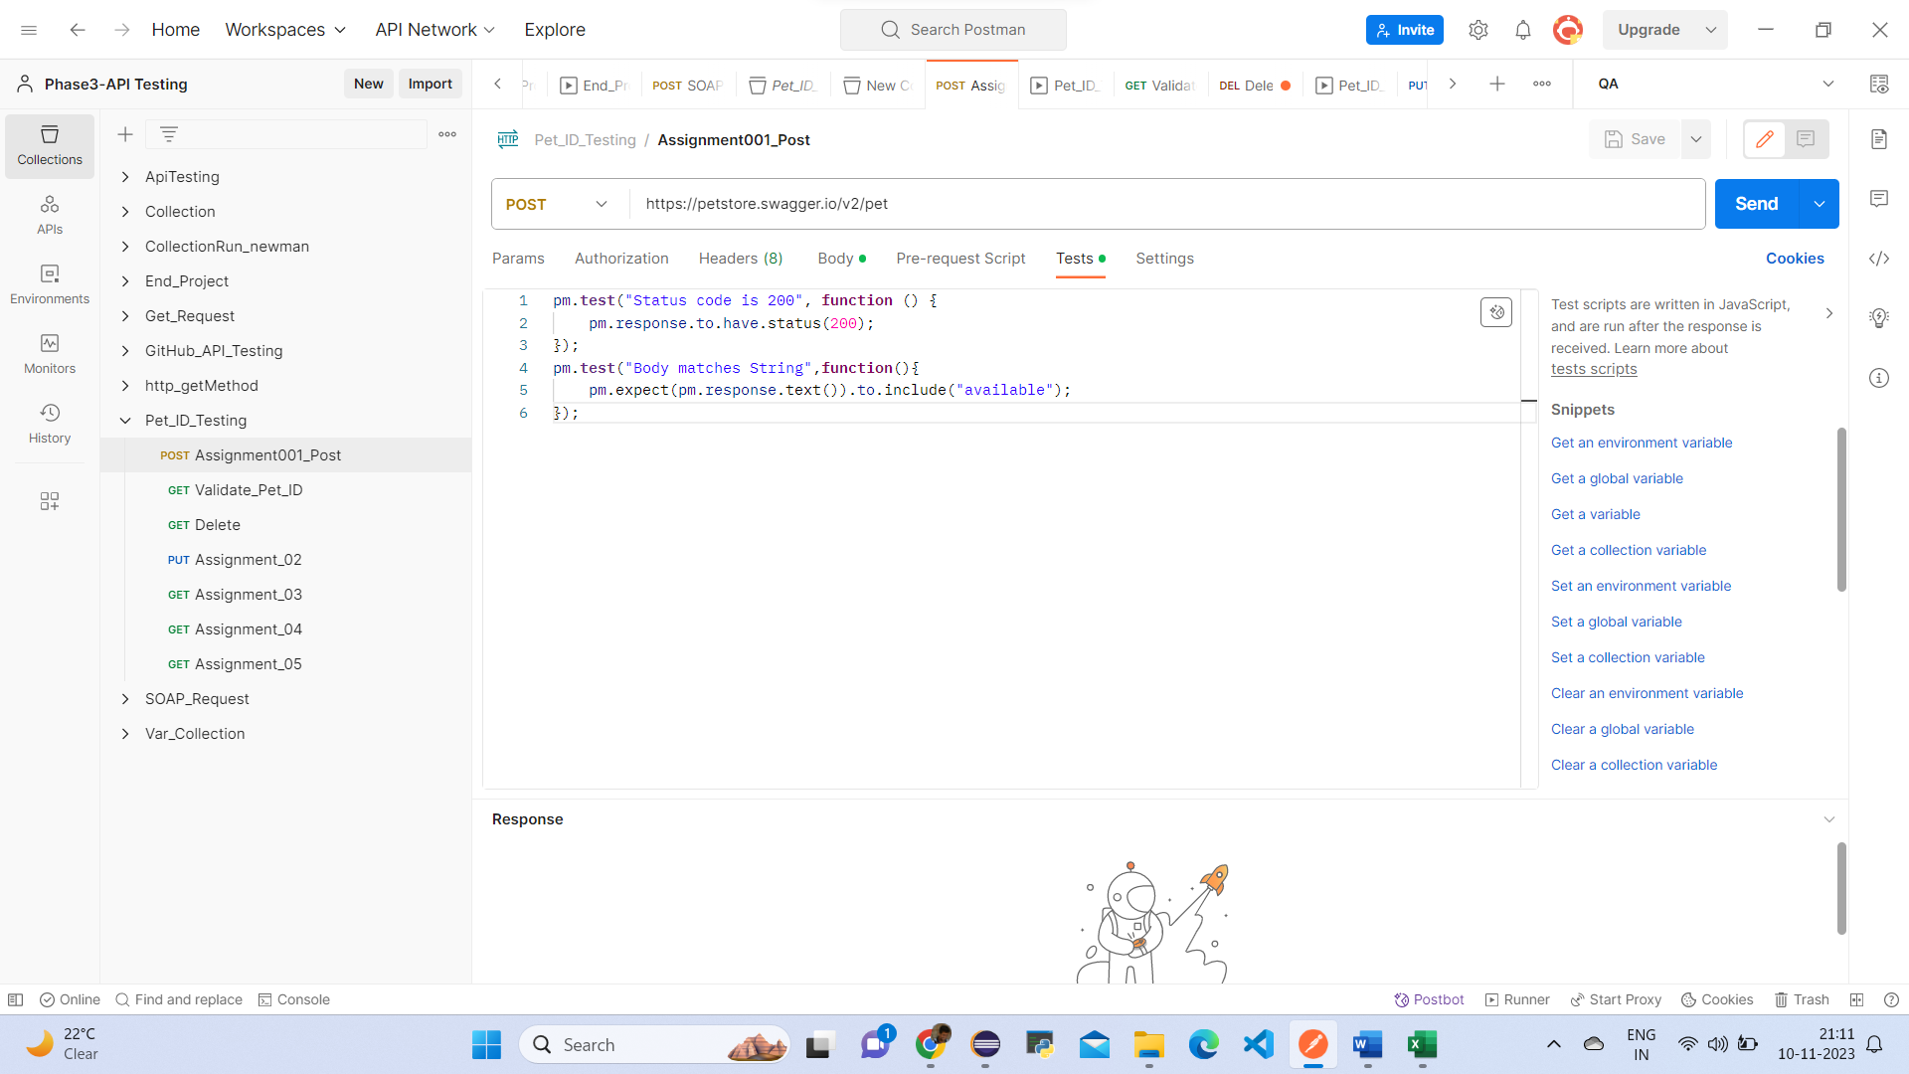

Run the Collection with Pets.csv file

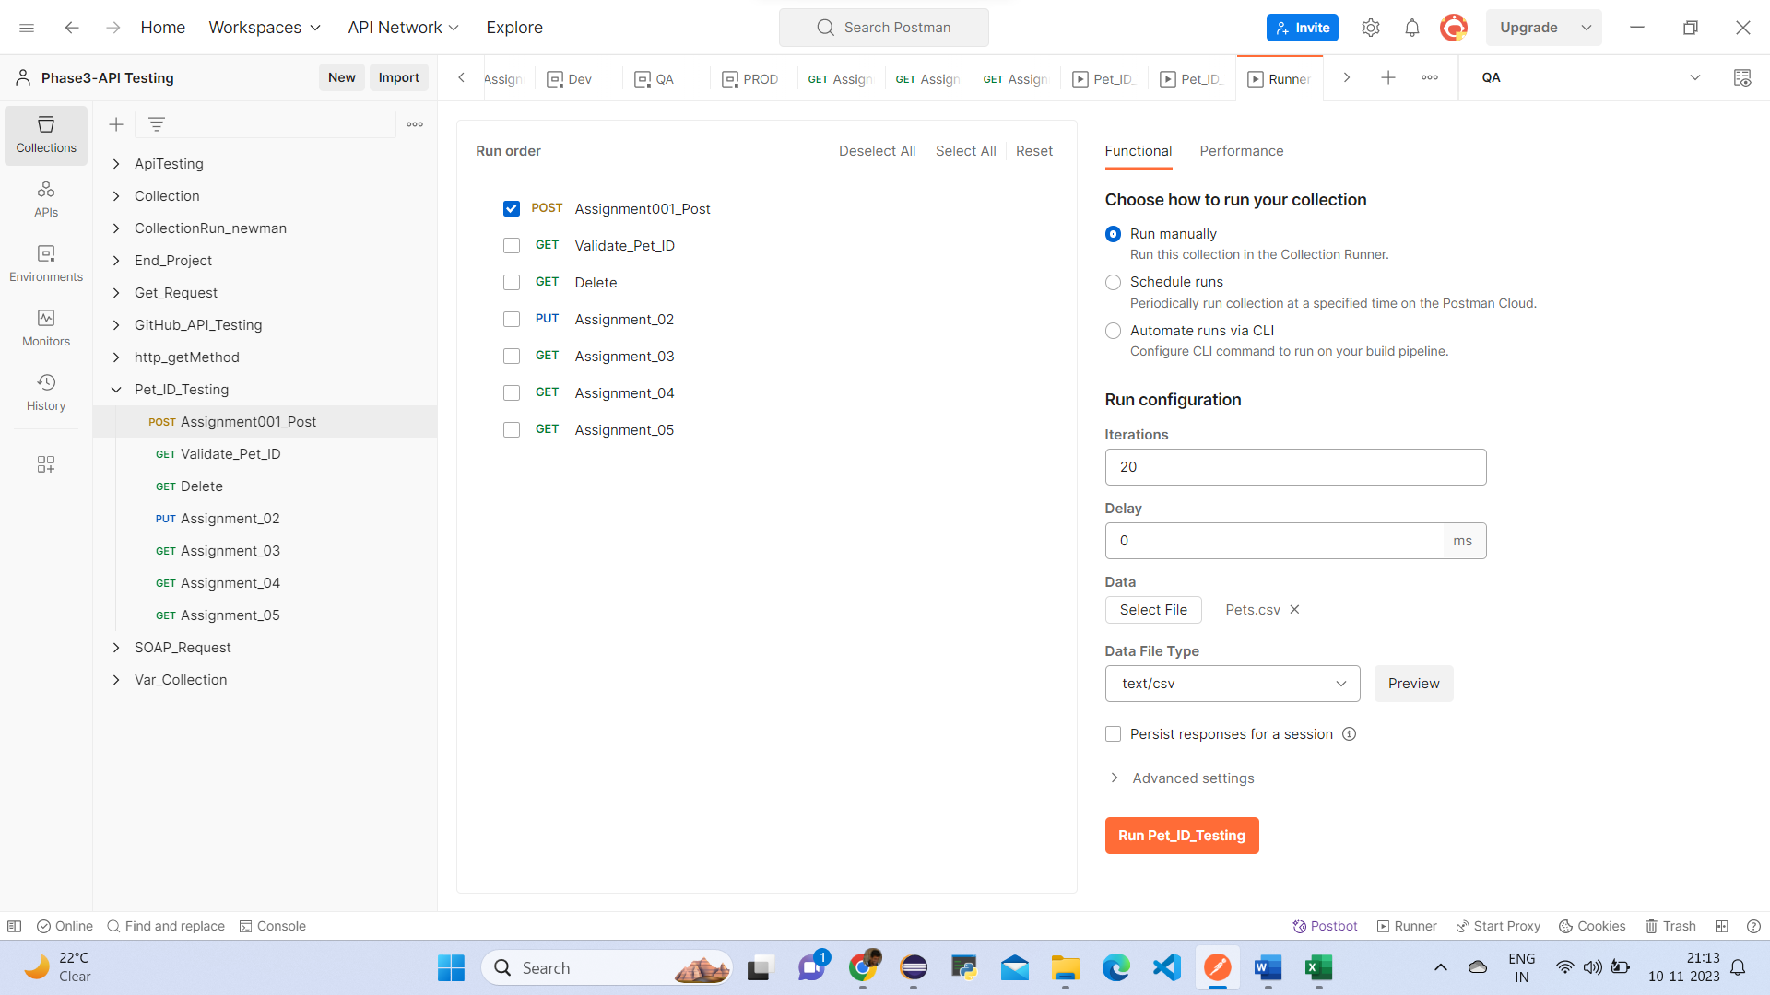

Click on Run Pet_ID_Testing

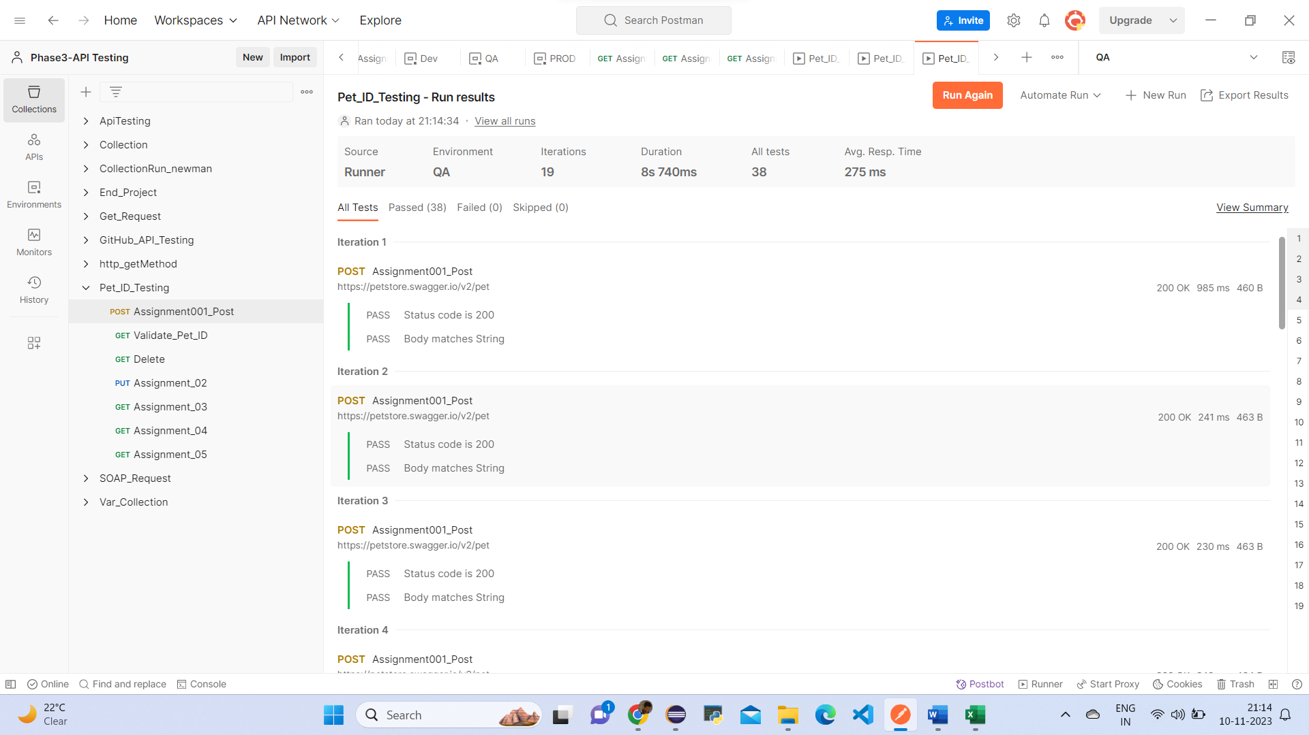

Validate petID:

In the collection, add a new GET service request with the following details.

Create the get request with the given URL

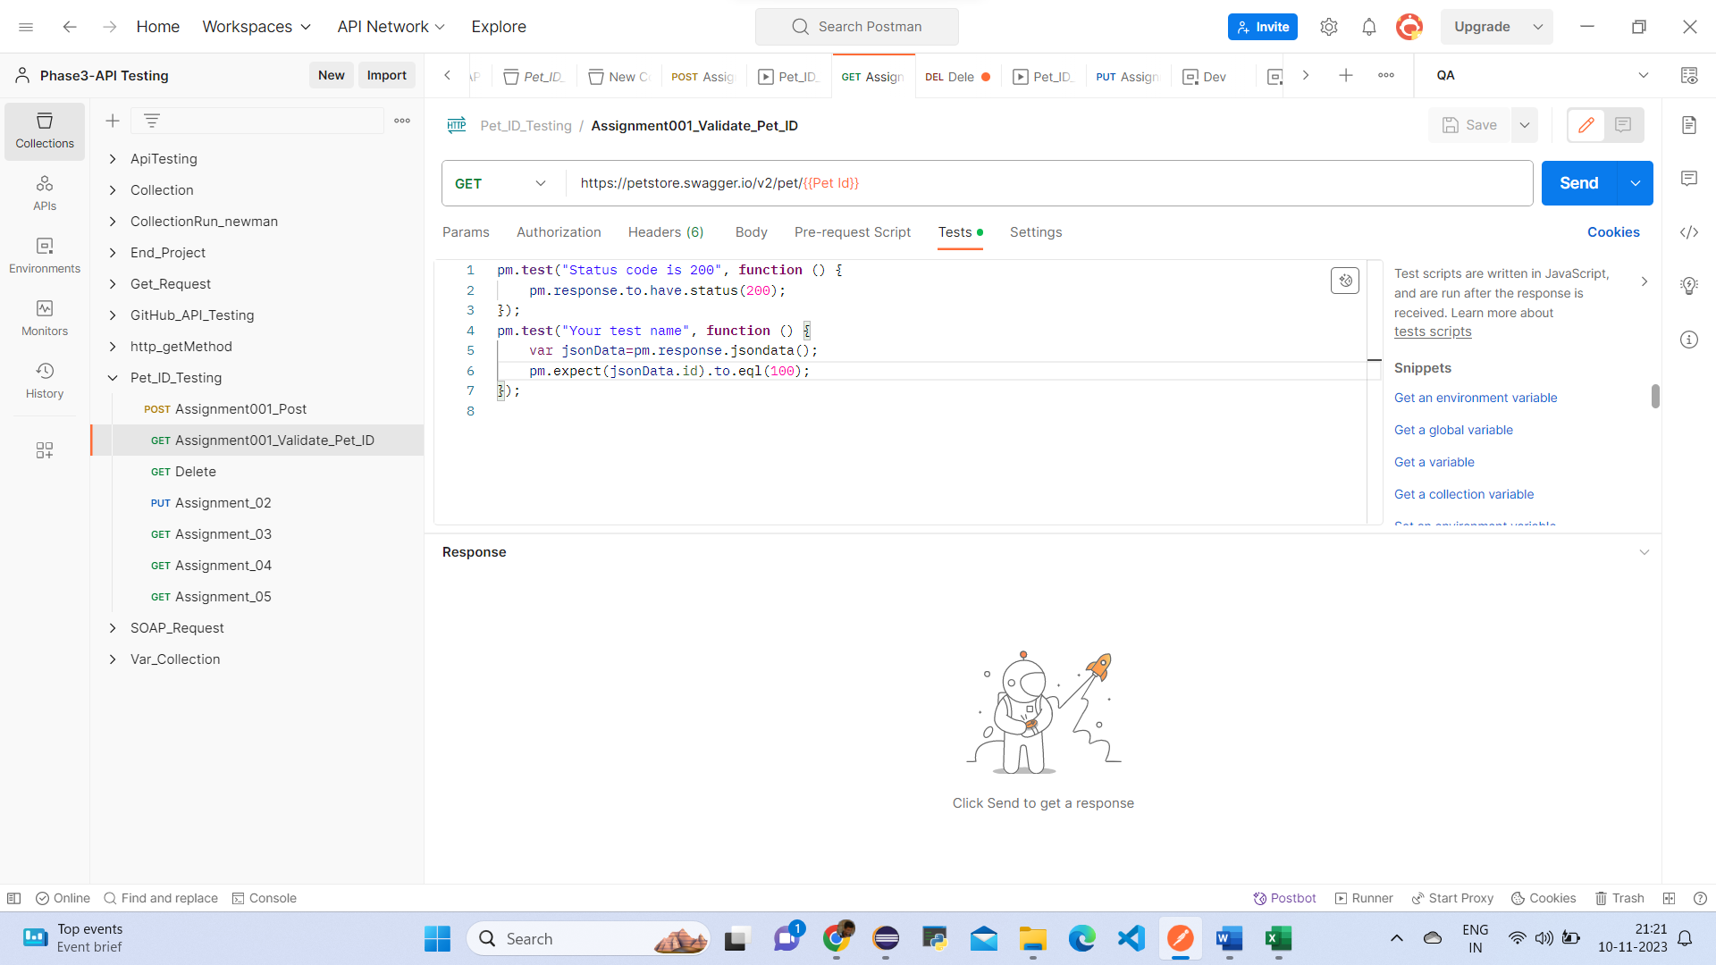

Response

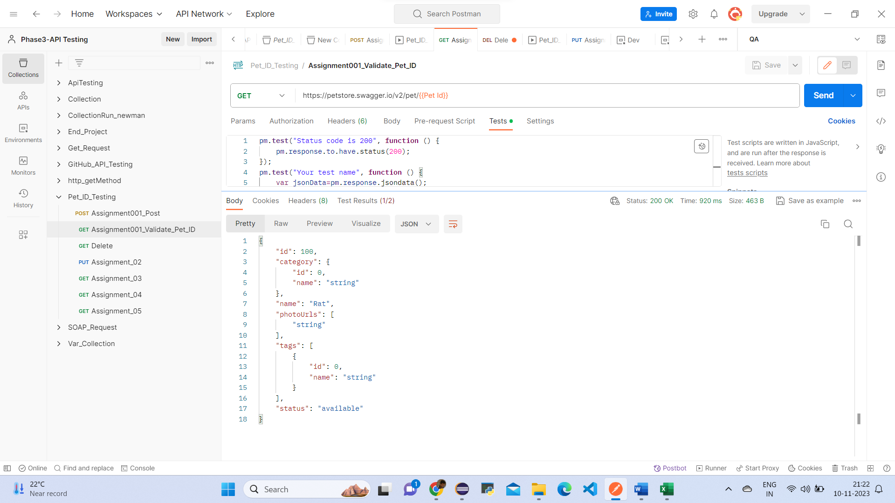

3.Validate_PetID

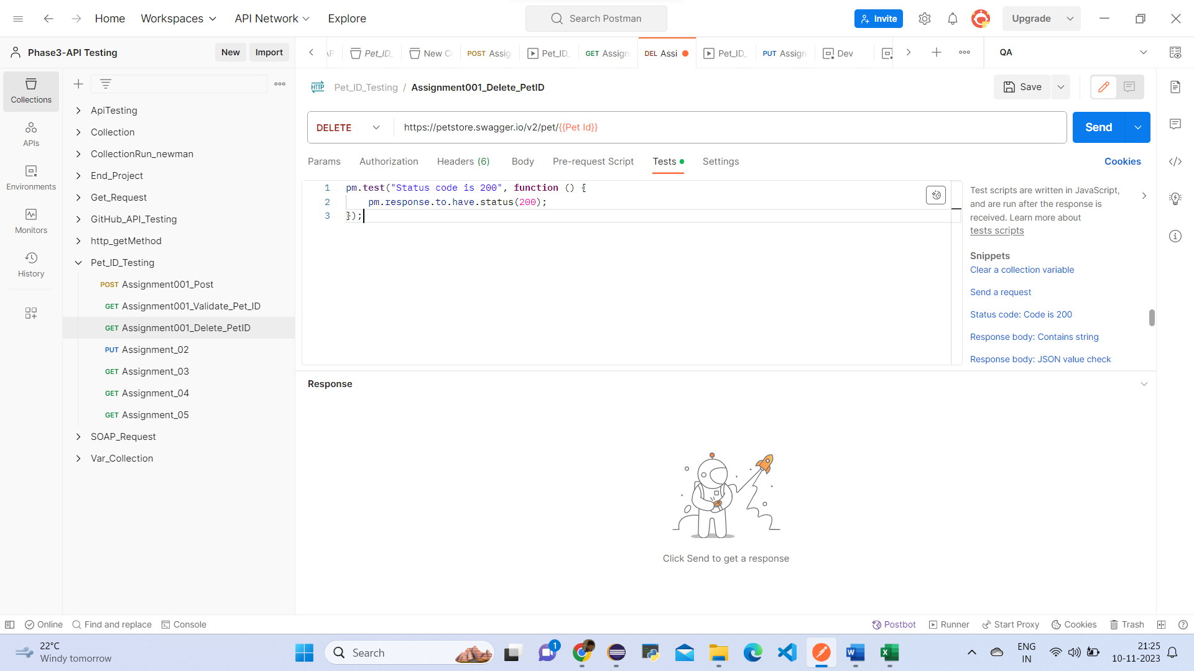

In the Postman Tests section validate for this GET call. Response status code should be 200.

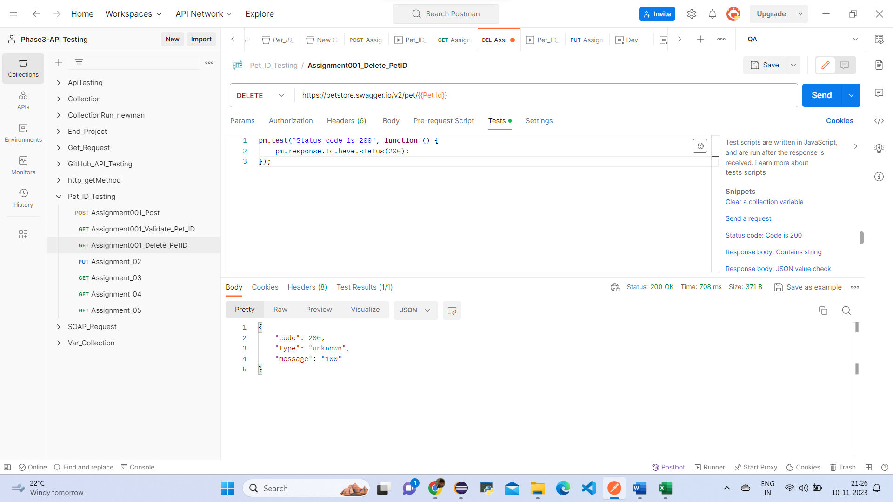

Postman Assignment_002:

● Hit a PUT call having service

URL = <https://petstore.swagger.io/v2/pet>

● Create a global variable of this URL where testURL is the variable name and its value is

https://petstore.swagger.io/v2/pet. Use this variable while hitting the URL in Postman.

● PUT Call request JSON body:

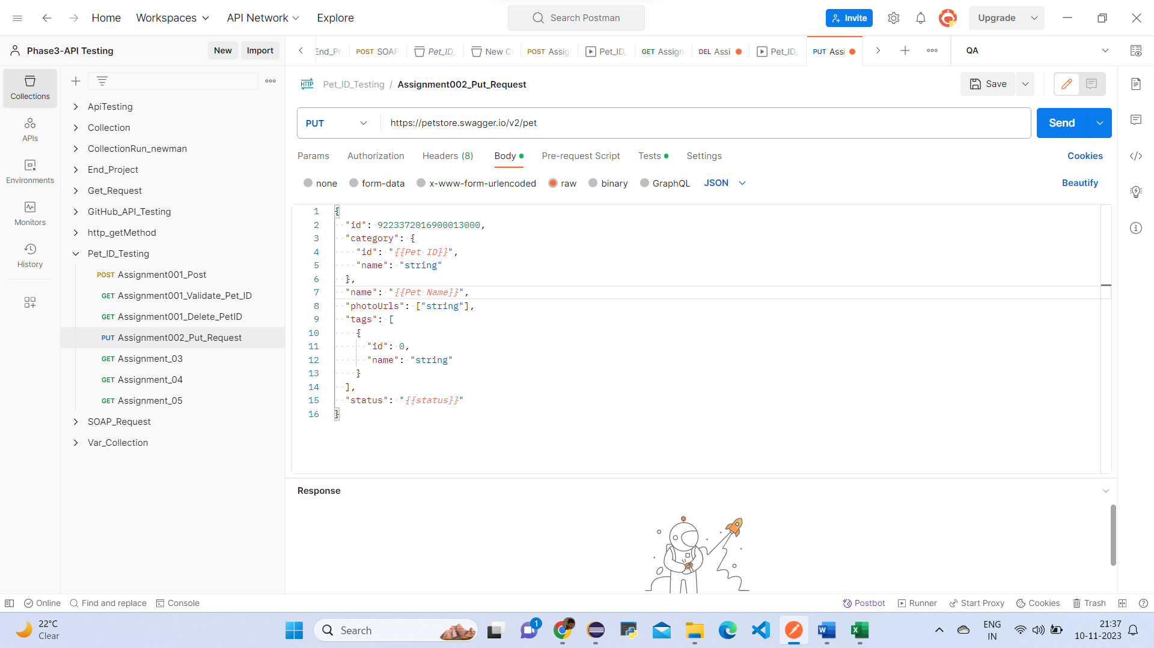

🡺Create 3 Environment Variable

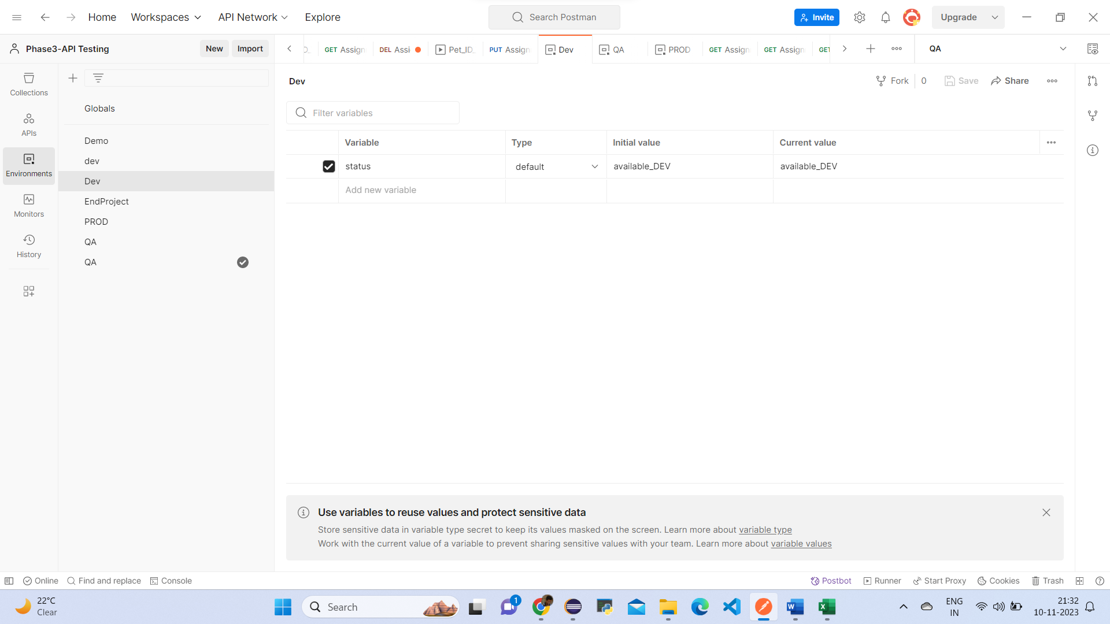

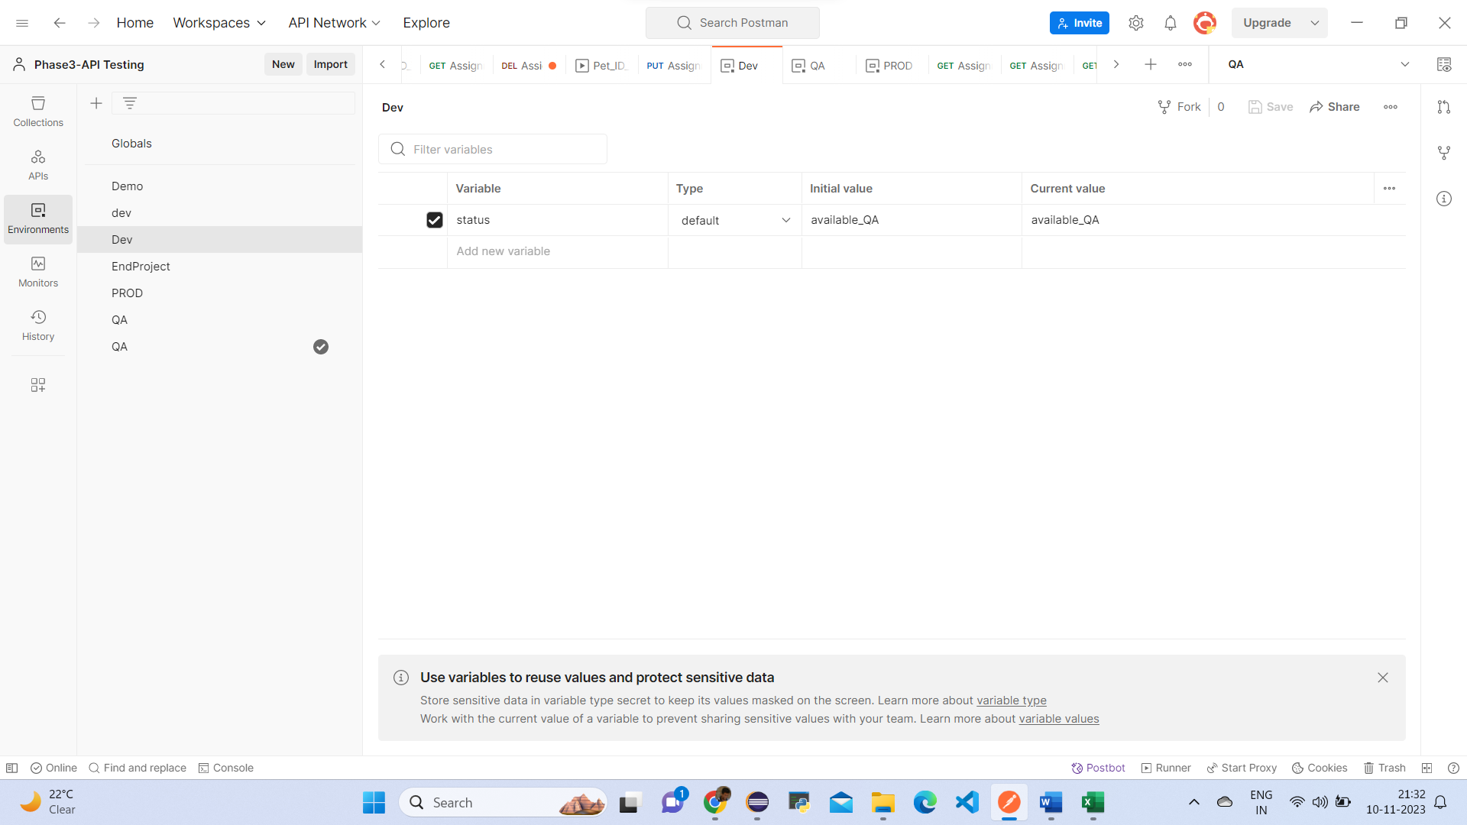

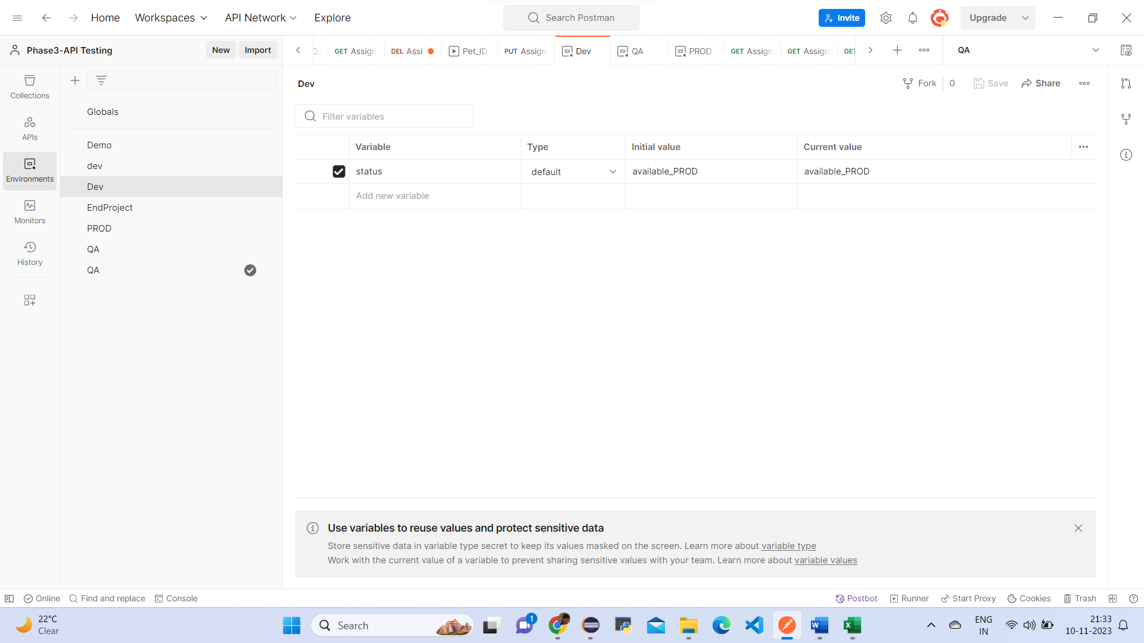

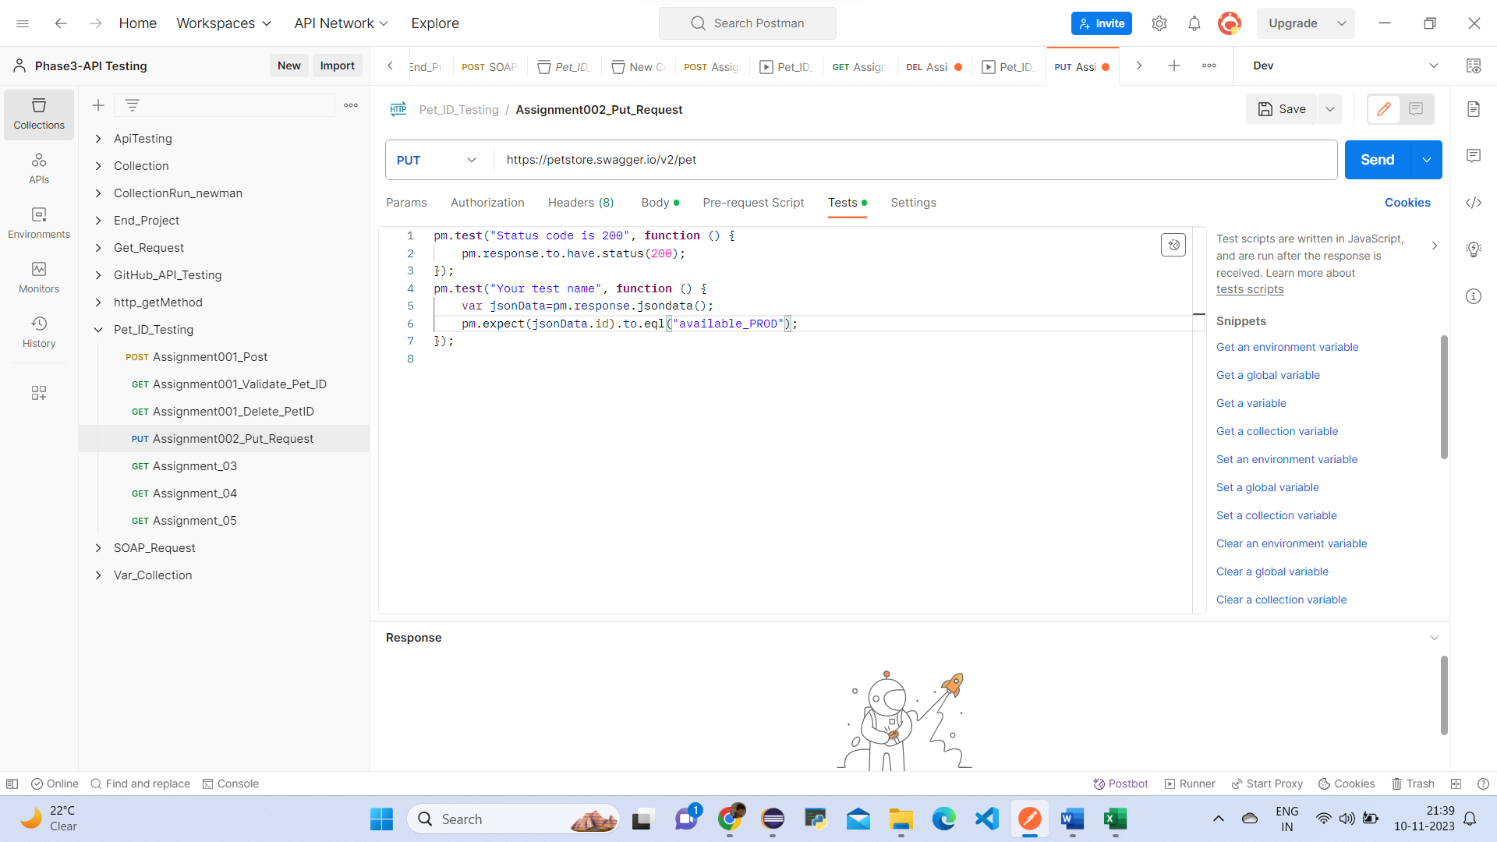

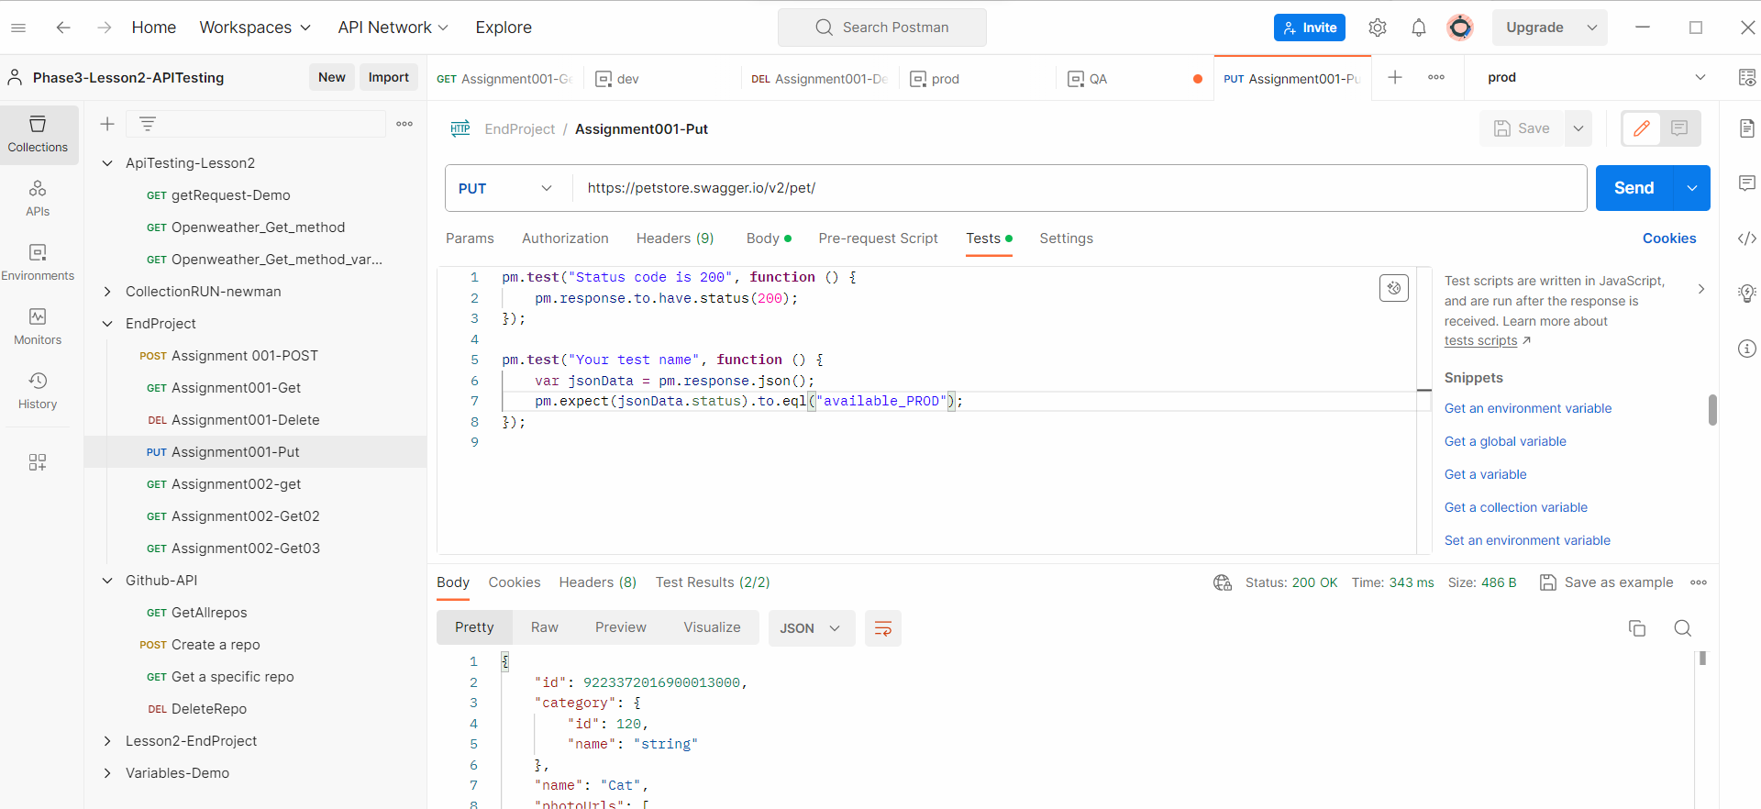

Postman Assignment_003:

● Hit a GET call with URL: <https://petstore.swagger.io/v2/user/Uname001>

● Use Uname001 as global parameter

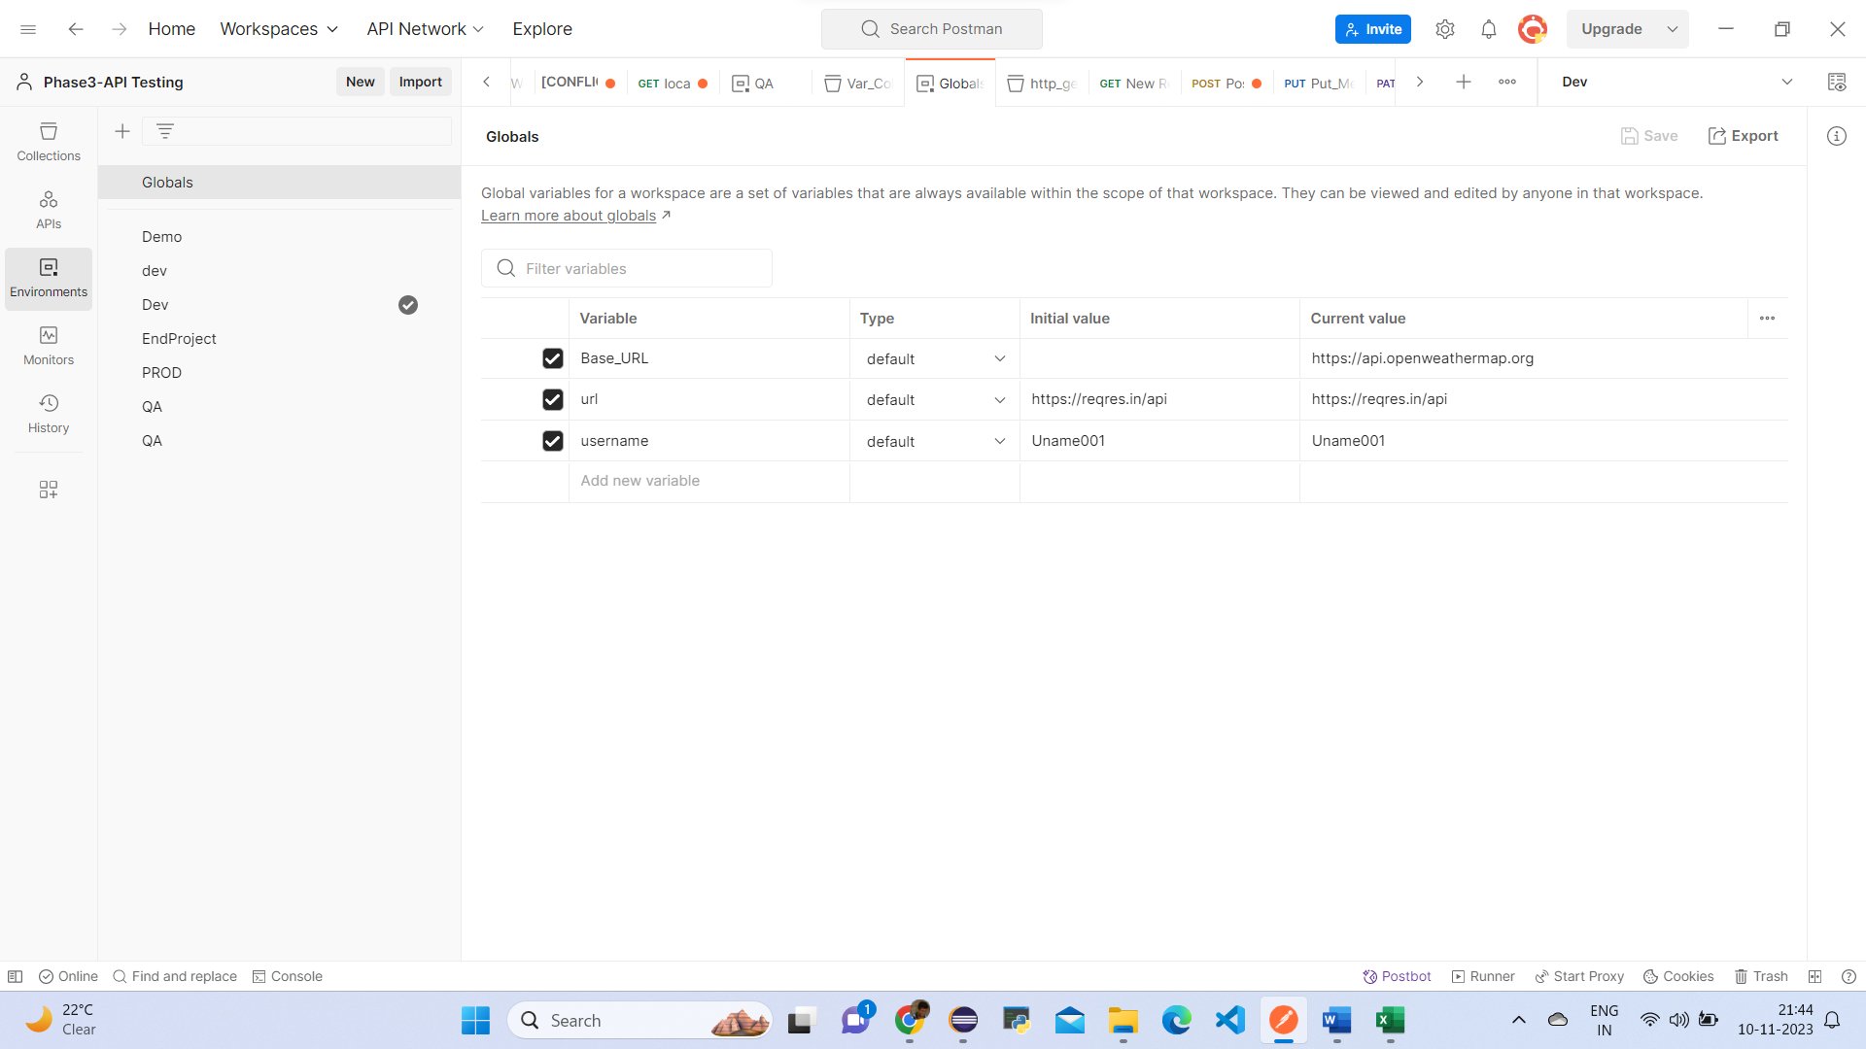

* Validate username = Uname001 in JSON response
* Validate email = Positive@Attitude.com in JSON response

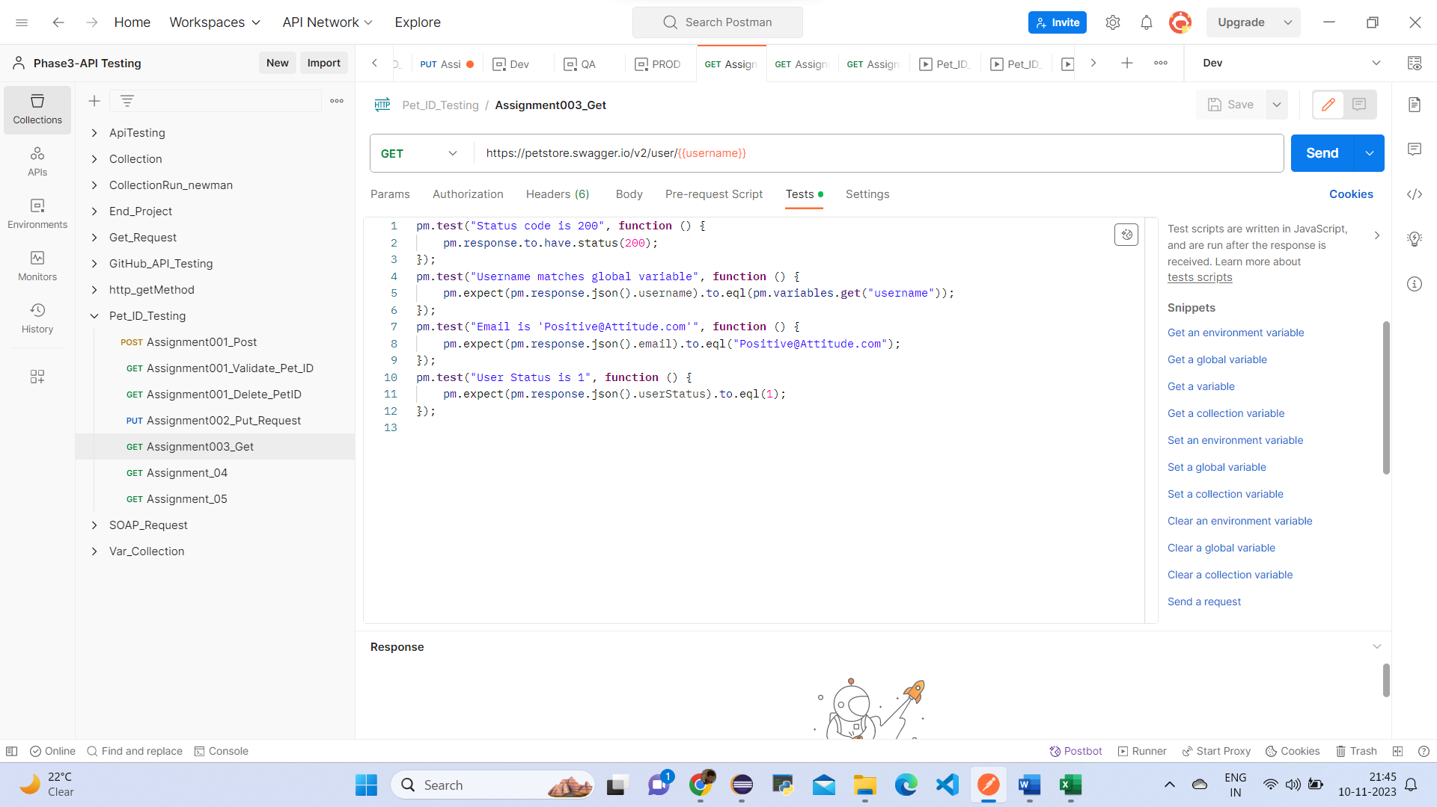

Validate response as 200 in Postman

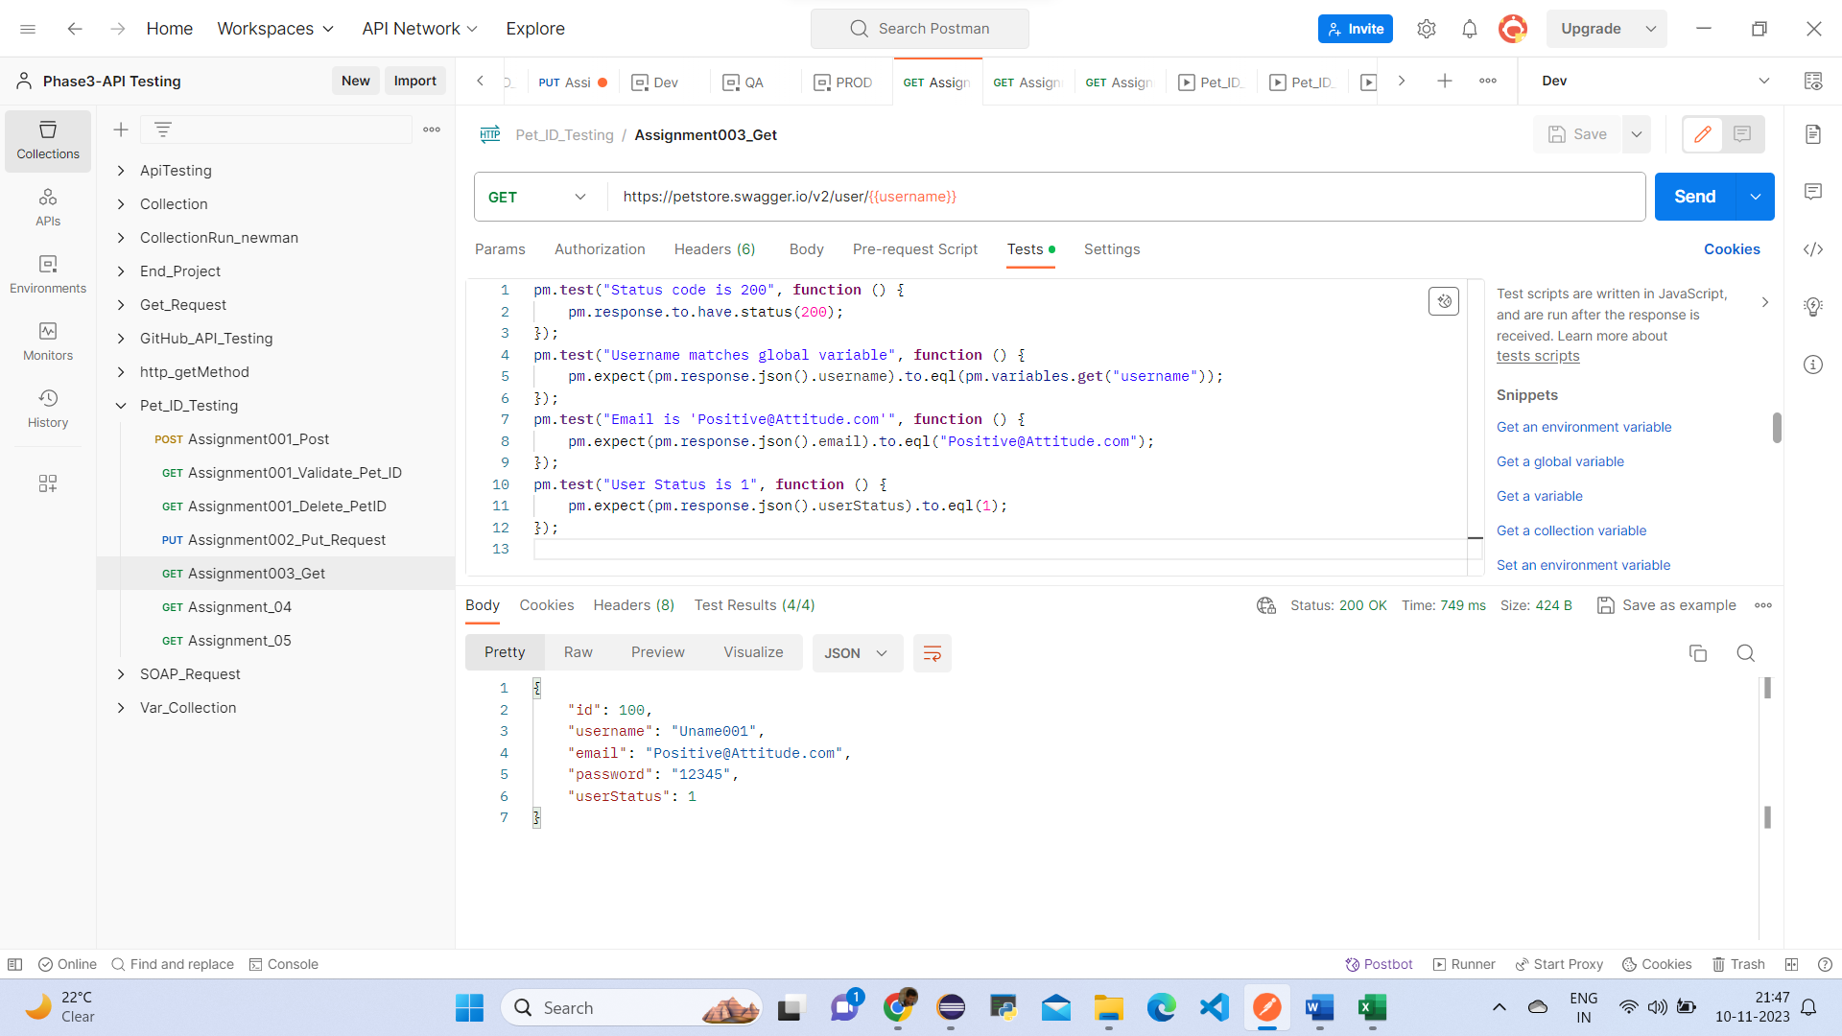

Postman Assignment_004:

● Hit a GET call with URL: <https://petstore.swagger.io/v2/pet/findByStatus>

● Use Postman params as status

● When status = available and if after hitting the URL, response status = 200, then validate for all pet details that their response status = available

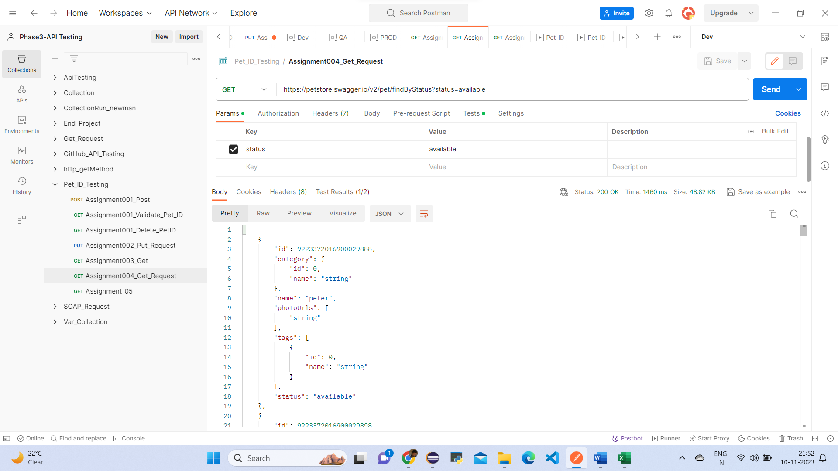

When status = pending and if after hitting the URL, response status = 200, then validate for all pet details that their response status = pending

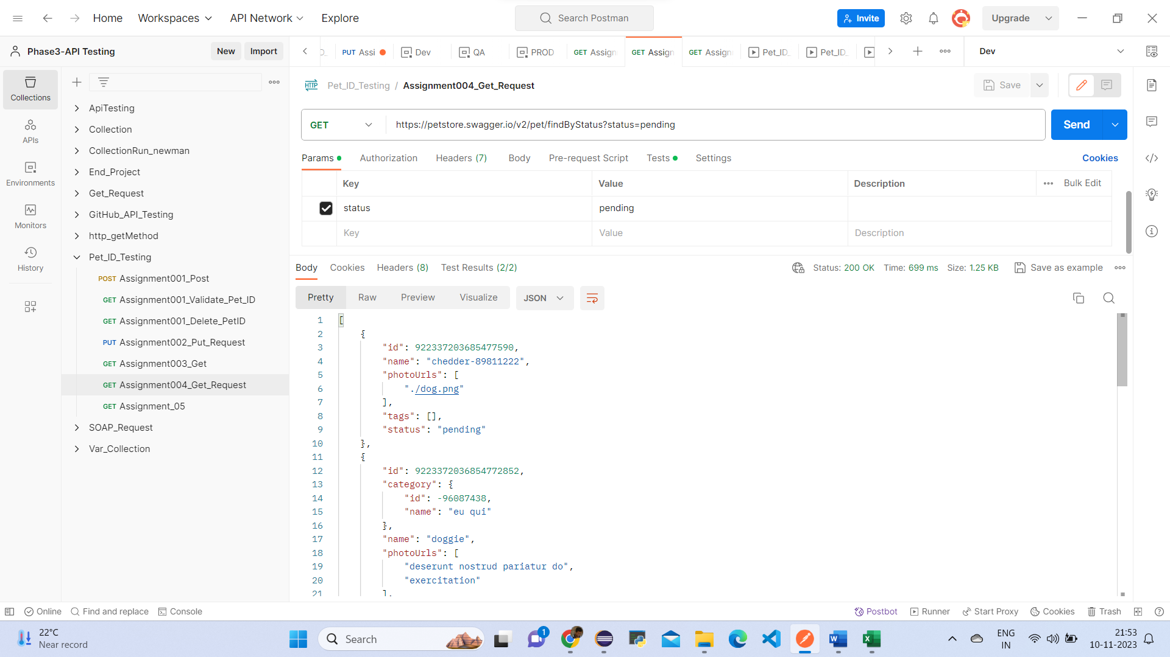

When status = sold and if after hitting the URL, response status = 200, then validate for all pet details that their response status = sold

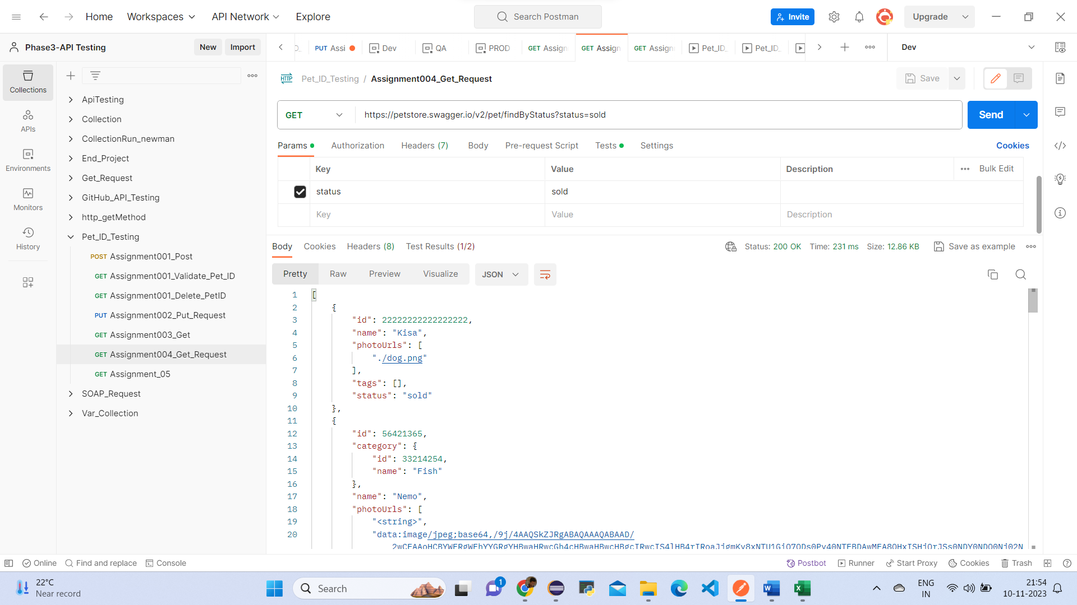

Postman Assignment_005:

● Hit a GET call with URL: <https://petstore.swagger.io/v2/user/logout>

● Validate response as 200 in Postman

● Validate code = 200 in response

● Validate message = OK in response

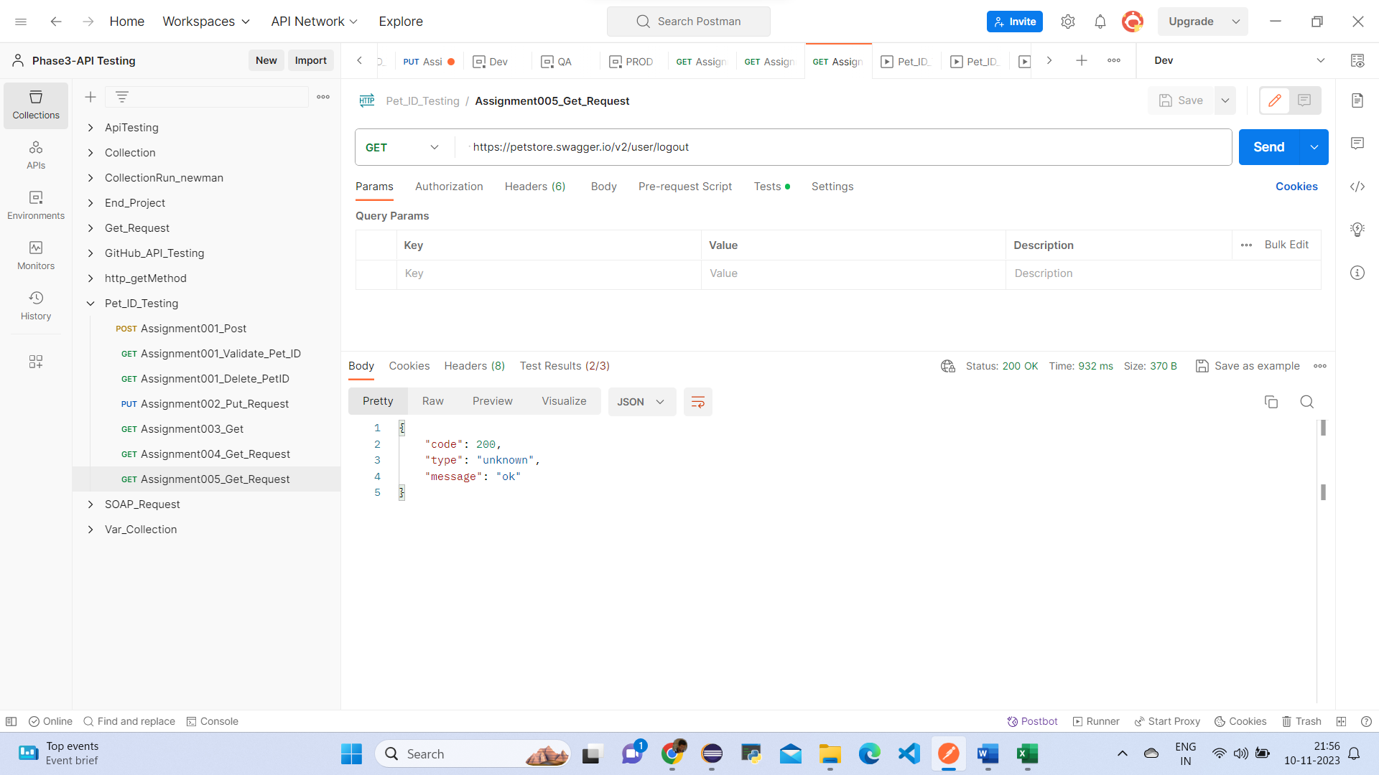

Rest Assured Assignment

Assignment001

🡺WriteUp:

Open Eclipse/IntelliJ

● Create a Maven project

● Add Maven dependency for TestNG and REST Assured

● Create a TestNG test with below REST API execution details

🡺Source Code:

package EndProject;

import java.io.File;

import org.apache.logging.log4j.LogManager; import org.apache.logging.log4j.Logger;

import org.hamcrest.Matchers;

import org.testng.annotations.Test;

import io.restassured.RestAssured; import io.restassured.http.ContentType;

public class Assignment001Demo {

Logger logger = LogManager.getLogger(Assignment001Demo.class);

@Test(priority='1') publicvoid assignment001Post() {

logger.info("Course End project - Assignment001 - POST request"); File file = new File("resources/data.json"); int id = RestAssured.given()

.baseUri("https://petstore.swagger.io/v2/pet")

.contentType(ContentType.JSON)

.body(file)

.when().post()

.then()

.statusCode(200)

.log().all()

.body("name", Matchers.equalTo("duck")).extract().path("id"); logger.trace("The status code is checked");

System.out.println(id);

logger.trace("Id has been captured and validated");

}

@Test(priority='2',dependsOnMethods="assignment001Post") public void assignment001Get()

{

logger.info("Course End project - Assignment001 - GET request"); int id = RestAssured.given()

.baseUri("https://petstore.swagger.io/v2/pet/987")

.when()

.get()

.then()

.statusCode(200)

.log().all()

.body("status", Matchers.equalTo("available")).extract().path("category.id"); System.out.println(id); // 0 logger.trace("Id and status has been captured and validated");

}

@Test(priority='3',dependsOnMethods="assignment001Get") public void assignment001Delete()

{

logger.info("Course End project - Assignment001 - Delete request");

RestAssured.given()

.baseUri("https://petstore.swagger.io/v2/pet/987")

.when()

.delete()

.then()

.statusCode(200)

.log().all()

.body("code", Matchers.equalTo(200))

.body("type", Matchers.equalTo("unknown"))

.body("message", Matchers.equalTo("987"));

}

}

🡺ScreenShot:

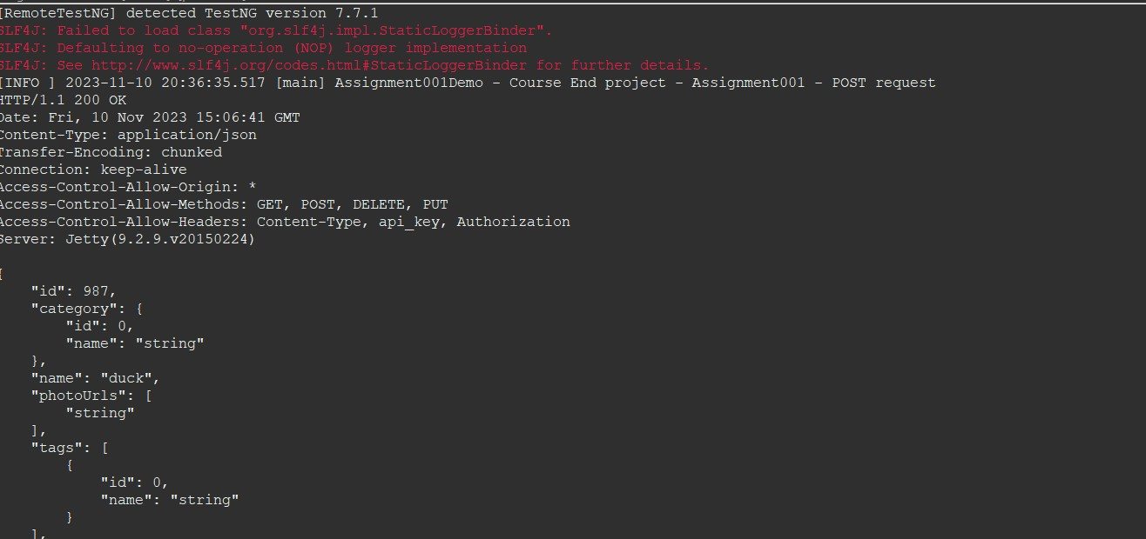

Assignment002

🡺WriteUp:

● Hit a PUT call having service URL = https://petstore.swagger.io/v2/pet

● PUT Call request JSON body:

{ "id": 9223372016900013000, "category": { "id": 20021, "name": "string"}, "name": "doggie", "photoUrls": [ "string" ], "tags": [ { "id": 0, "name": "string" }], "status": "available_QA" }

● Create three test environments as DEV, QA, PROD, where PUT call JSON body status field should be parameterized and its value should change as per environment:

○ When Environment is DEV then "status": "available_DEV"

○ When Environment is QA then "status": "available_QA"

○ When Environment is PROD then "status": "available_PROD"

● All assertion/validation should be done using Hamcrest.

● Validate response as 200 ● Validate id = 20021 in response

● Validate status value is changing as per environment in JSON response

🡺Source Code:

**package** EndProject;

**import** java.io.File;

**import** org.hamcrest.Matchers;

**import** org.testng.annotations.Test;

**import** io.restassured.RestAssured;

**import** io.restassured.http.ContentType;

**public** **class** Assignment002Demo {

@Test(priority='1')

**public** **void** assignment002Put()

{

File file = **new** File("resources/dataput.json");

**long** id = RestAssured.*given*()

.baseUri("https://petstore.swagger.io/v2/pet/")

.contentType(ContentType.***JSON***)

.body(file)

.when()

.post()

.then()

.statusCode(200)

.log().all()

.body("status", Matchers.*equalTo*("available_QA")).extract().path("id");

System.***out***.println(id);

}

@Test(priority='2')

**public** **void** assignment002login()

{

RestAssured.*given*()

.baseUri("https://petstore.swagger.io/v2/user/login")

.auth().preemptive().basic("Uname001", "@tt!tude")

.when()

.get()

.then()

.statusCode(200)

.log().all()

.body("message", Matchers.*contains*("logged in user session"));

}

}

🡺ScreenShot:

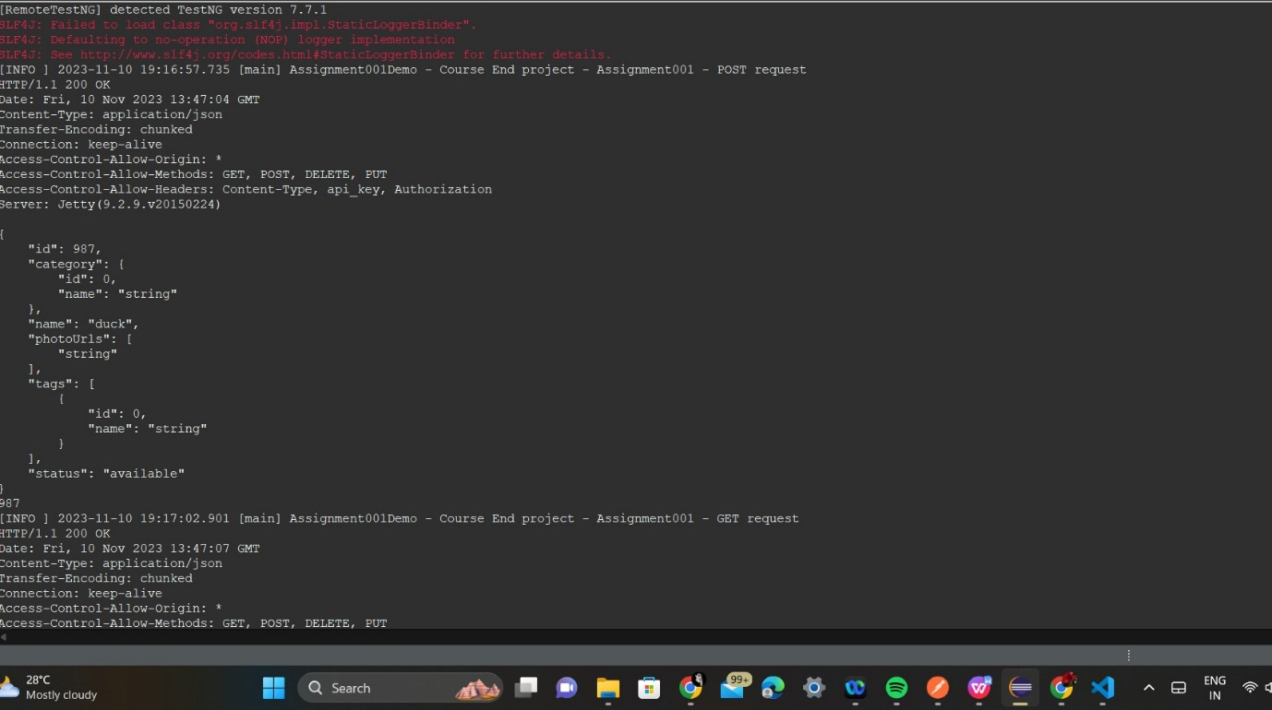

Assignment003:

🡺WriteUp:

Create a TestNG test and implement the scenario

● Hit a GET call with URL: <https://petstore.swagger.io/v2/user/Uname001>

● All assertion/validation should be done using Hamcrest

● Validate response as 200

● Validate username = Uname001 in JSON response

● Validate email = Positive@Attitude.com in JSON response

● Validate userStatus = 1 in JSON response

🡺Source Code:

**package** EndProject;

**import** org.hamcrest.Matchers;

**import** org.testng.annotations.Test;

**import** io.restassured.RestAssured;

**public** **class** Assignment003Demo {

@Test(priority='1')

**public** **void** assignment003User()

{

RestAssured.*given*()

.baseUri("https://petstore.swagger.io/v2/user/Uname001")

.when()

.get()

.then()

.statusCode(200)

.log().all()

.body("username", Matchers.*equalTo*("Uname001"))

.body("email", Matchers.*equalTo*("Positive@Attitude.com"))

.body("userStatus", Matchers.*equalTo*(1));

}

}

🡺ScreenShot:

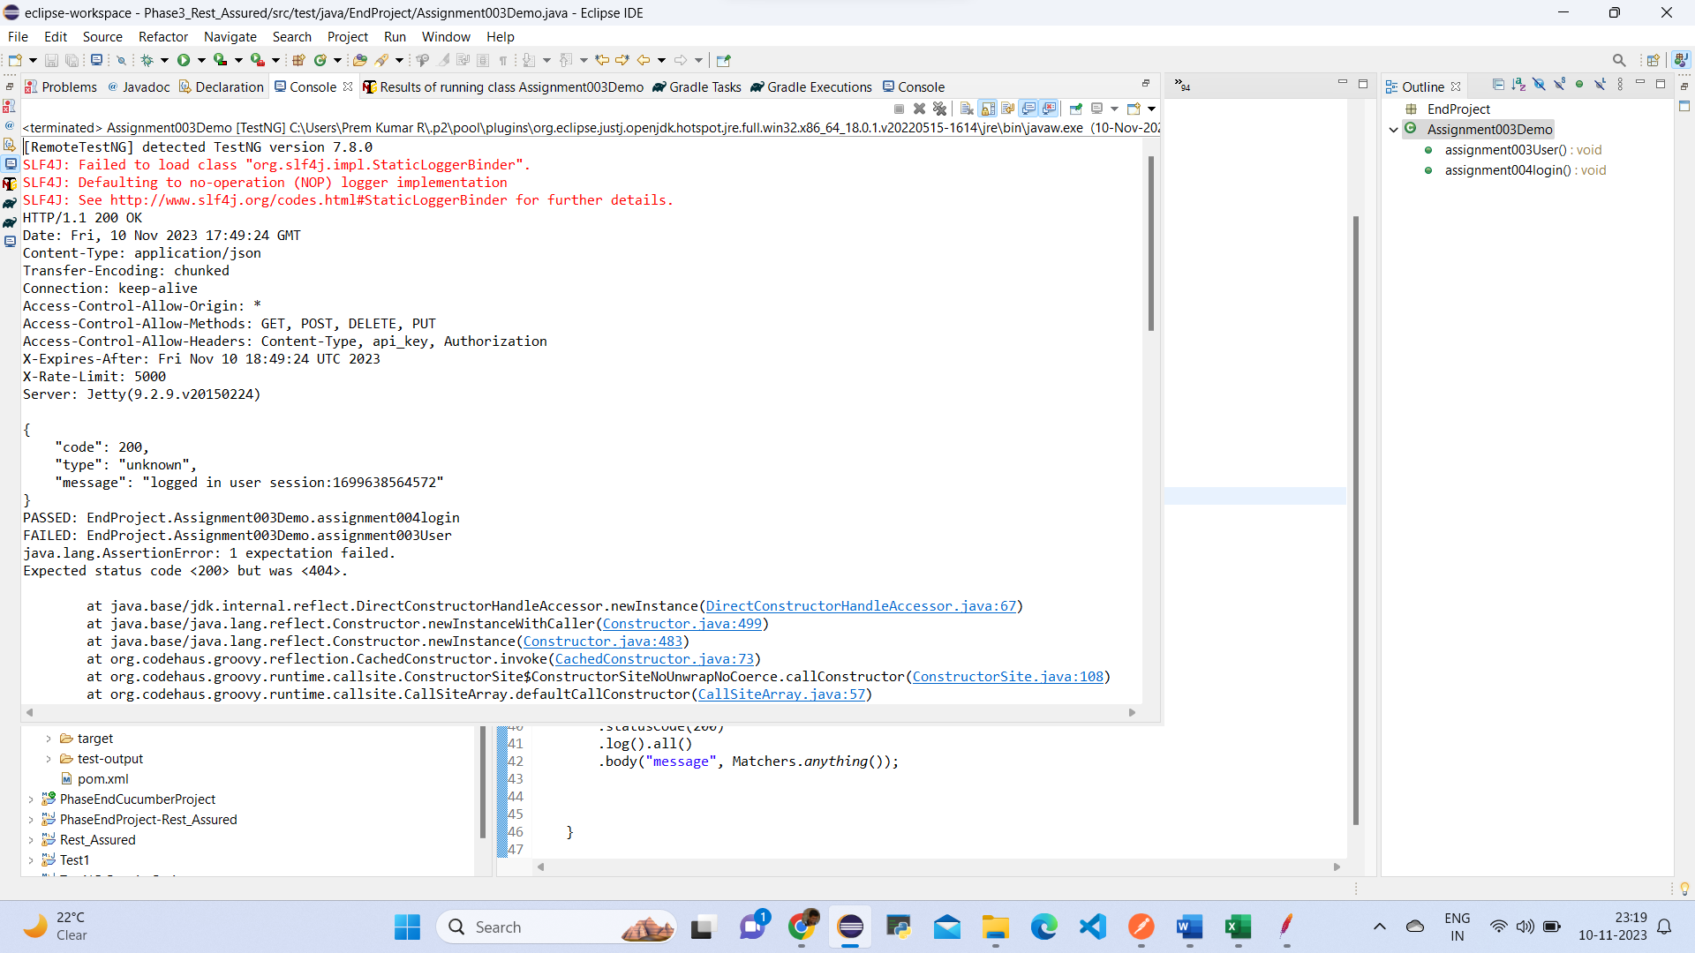

Assignment004

🡺WriteUp:

Create a TestNG test and implement the below scenario

● Hit a GET call with URL: <https://petstore.swagger.io/v2/user/login>

● Use REST Assured basic authentication with username = Uname001 and password = @tt!tude

● All assertion/validation should be done using Hamcrest

● Validate code = 200 in response

● Validate response message contains text ‘logged in user session’

🡺Source Code:

**package** EndProject;

**import** org.hamcrest.Matchers;

**import** org.testng.annotations.Test;

**import** io.restassured.RestAssured;

**public** **class** Assignment004 {

@Test(priority='1')

**public** **void** assignment004login()

{

RestAssured.*given*()

.baseUri("https://petstore.swagger.io/v2/user/login")

.auth().preemptive().basic("Uname001", "@tt!tude")

.when()

.get()

.then()

.statusCode(200)

.log().all()

.body("message", Matchers.*anything*());

}

}

🡺ScreenShot:

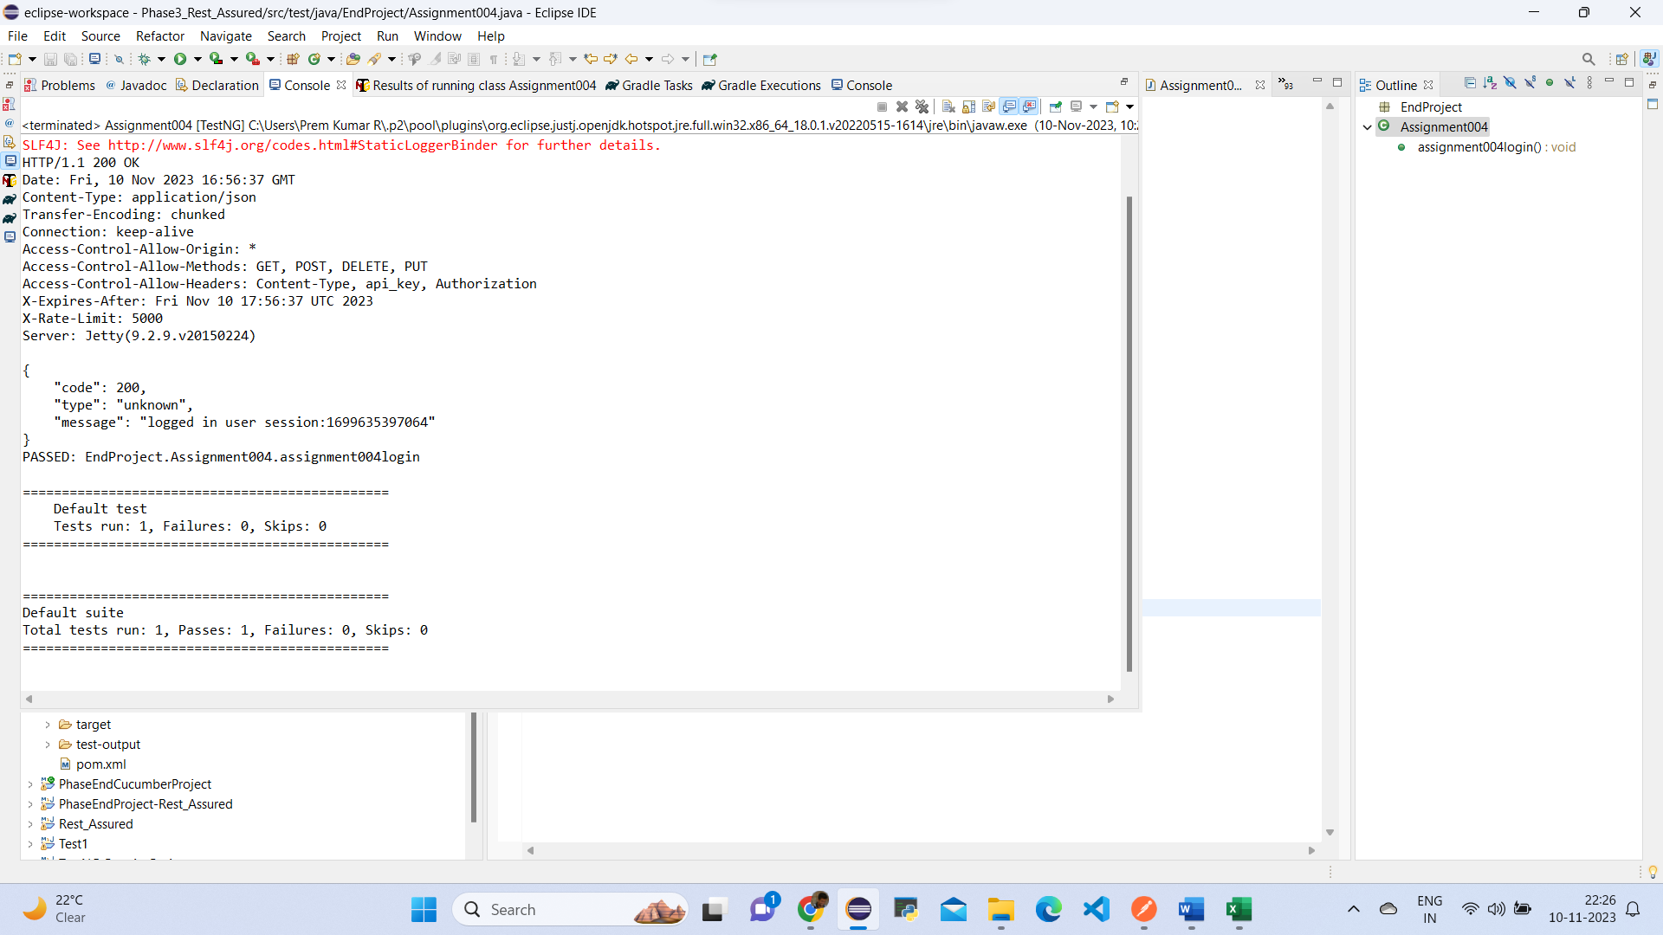

Assignment005

🡺WriteUp:

Create a TestNG test and implement the below scenario

● Hit a GET call with URL: <https://petstore.swagger.io/v2/pet/findByStatus>

● Use REST Assured params as status

● All assertion/validation should be done using Hamcrest

● When status = available and if after hitting the URL, response status = 200, then validate for all pet details that their response status = available

● When status = pending and if after hitting the URL, response status = 200, then validate for all pet details that their response status = pending

● When status = sold and if after hitting the URL, response status = 200, then validate for all pet details that their response status = sold

🡺Source Code:

**package** EndProject;

**import** org.hamcrest.Matchers;

**import** org.testng.annotations.Test;

**import** io.restassured.RestAssured;

**public** **class** Assignment005Demo {

@Test(priority='1')

**public** **void** assignment005FindByStatus()

{

RestAssured.*given*()

.baseUri("https://petstore.swagger.io/v2/pet/findByStatus")

.queryParam("status", "available")

.queryParam("status", "pending")

.queryParam("status", "sold")

.when()

.get()

.then()

.statusCode(200)

.log().all();

}

}

🡺ScreenShot:

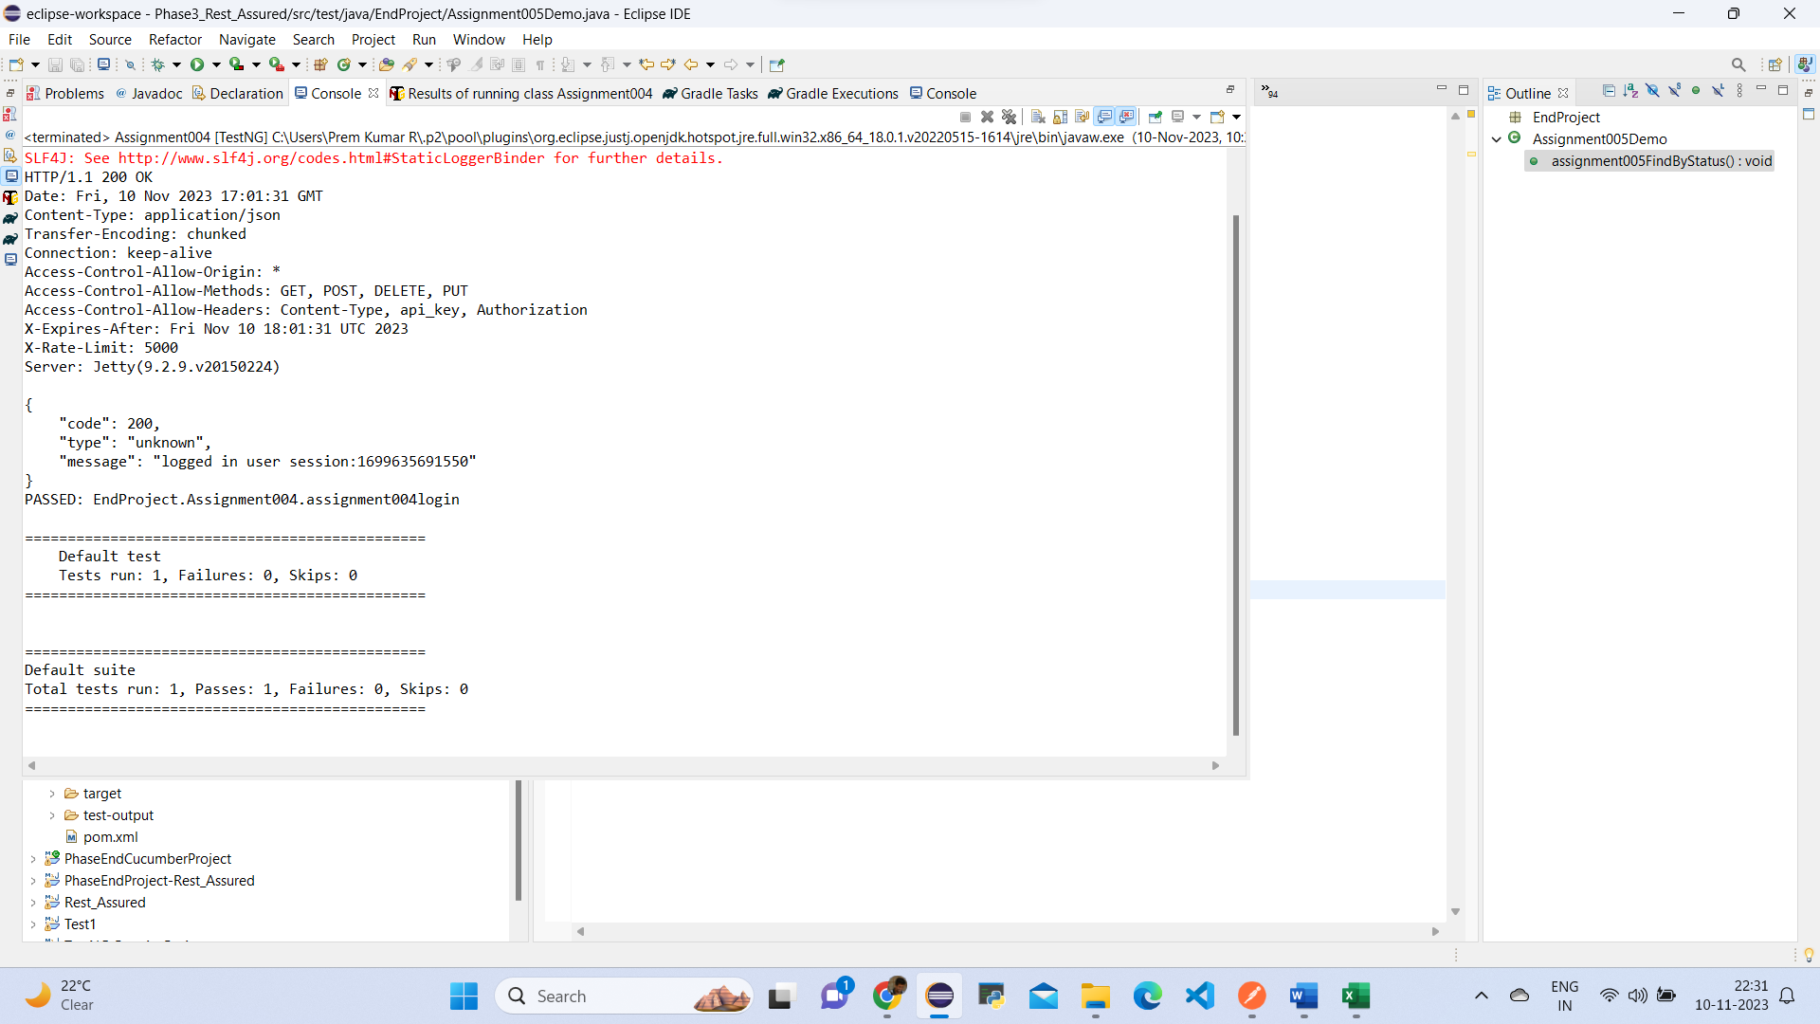

Assignment006:

🡺WriteUp:

Create a TestNG test and implement the below scenario

● Hit a GET call with URL: <https://petstore.swagger.io/v2/user/logout>

● All assertion/validation should be done using Hamcrest

● Validate response as 200

● Validate code = 200 in response

● Validate message = OK in response

🡺Source Code:

**package** EndProject;

**import** org.hamcrest.Matchers;

**import** org.testng.annotations.Test;

**import** io.restassured.RestAssured;

@Test

**public** **class** Assignment006{

**public** **void** assignment006Logout()

{

RestAssured.*given*()

.baseUri("https://petstore.swagger.io/v2/user/logout")

.when()

.get()

.then()

.statusCode(200)

.log().all()

.body("code", Matchers.*equalTo*(200))

.body("type", Matchers.*equalTo*("unknown"))

.body("message", Matchers.*equalTo*("ok"));

}

}

🡺ScreenShot:

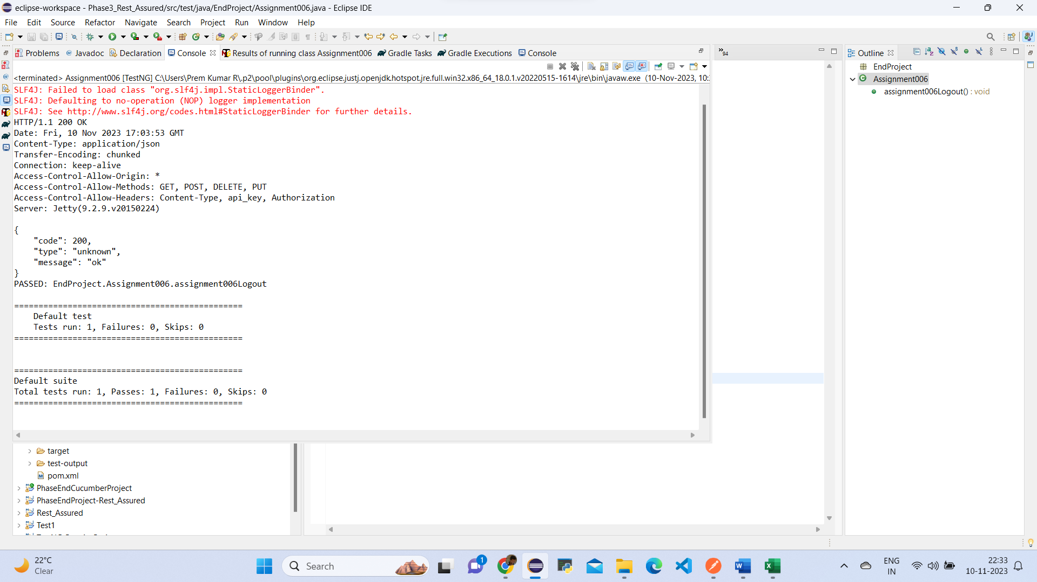

Jmeter Assignment:

🡺WriteUp:

Open JMeter

● Validate https://httpbin.org/basic-auth/user/passwd link using HTTP Authentication manager

● Default username is user, and the default password is passwd

● Validate response is a JSON file using JSON assertion

● Using HTTP sampler, hit https://www.simplilearn.com and validate xpath as //img[@title='Simplilearn - Online Certification Training Course Provider']

● Increase the thread count and do lead testing

Click on test plan🡪Add🡪Threads(Users)🡪Thread Group

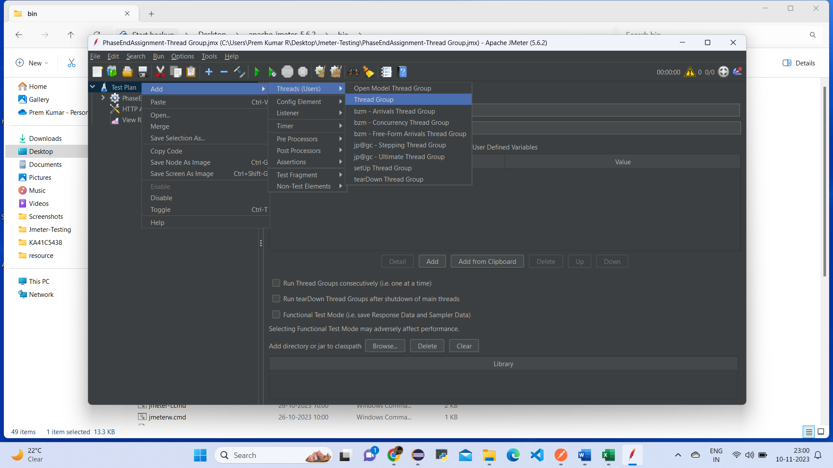

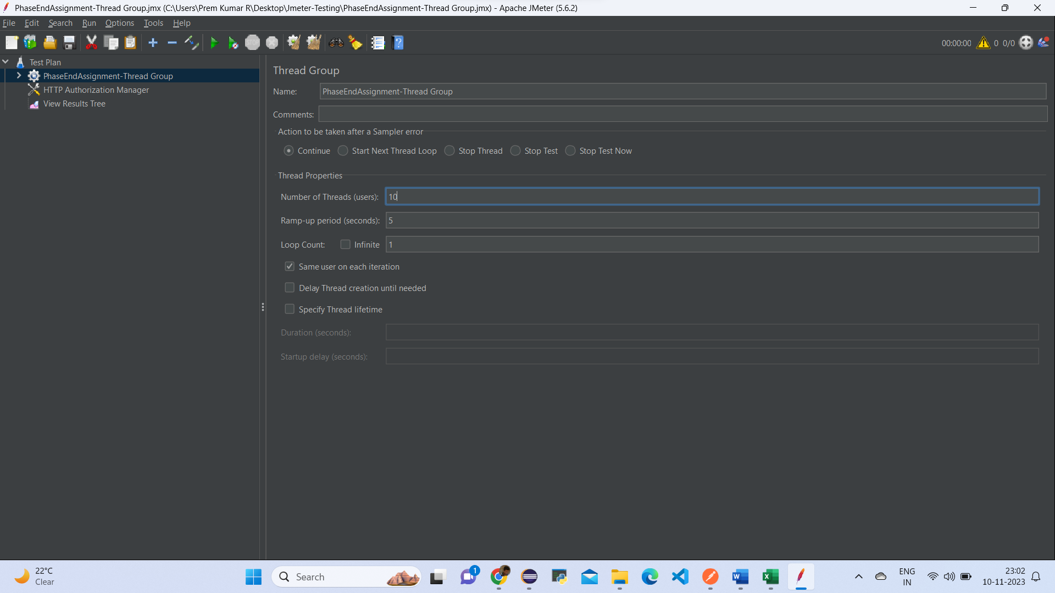

Click on thread group🡪Add🡪Sampler🡪HTTP Request

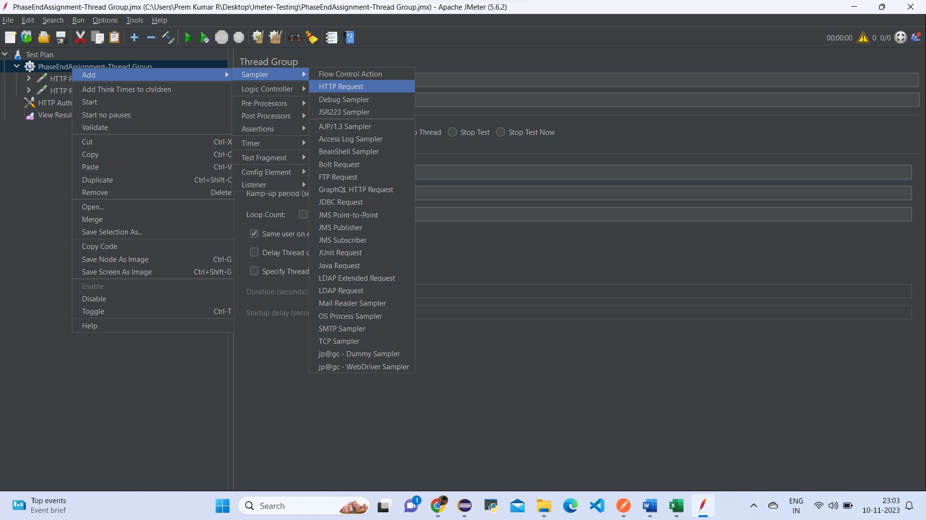

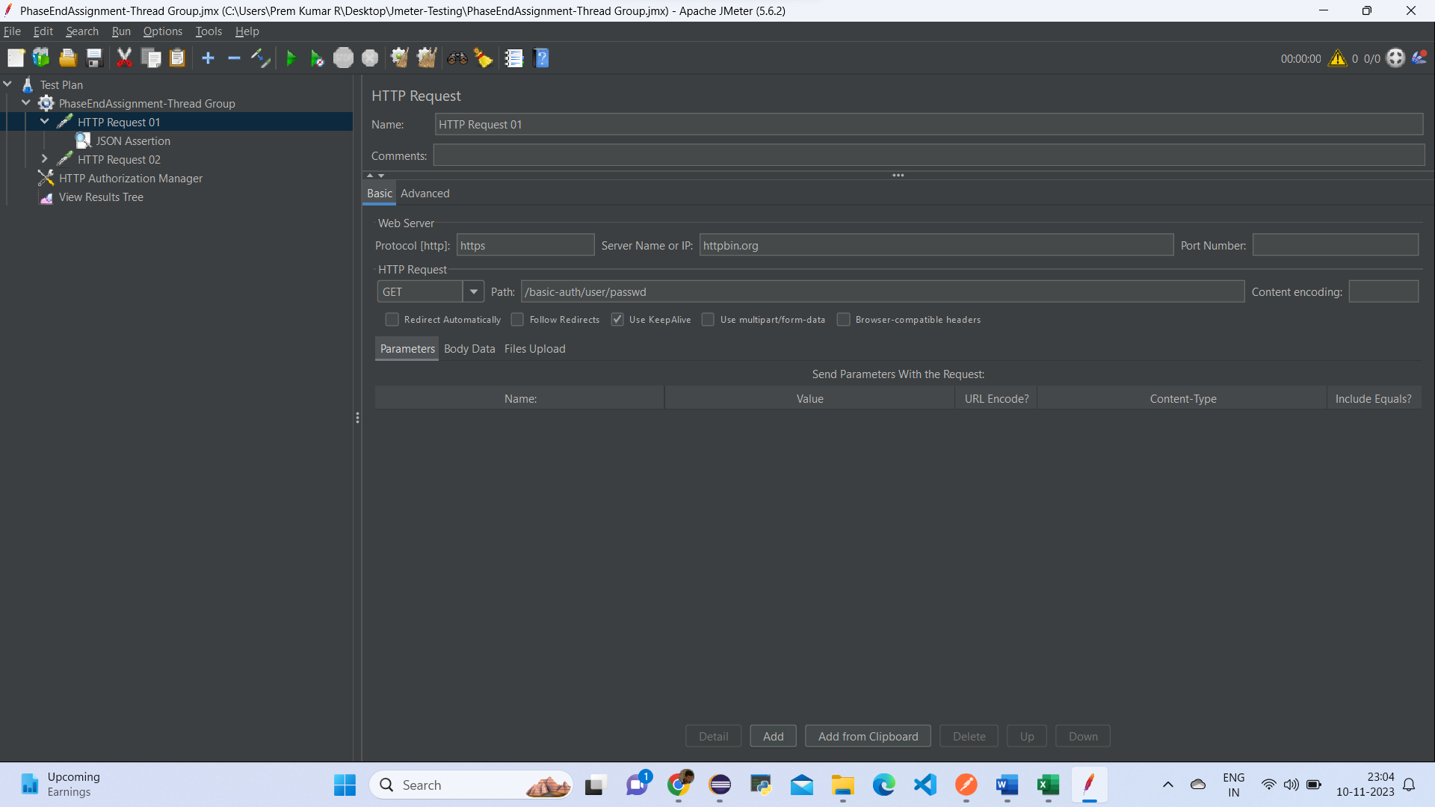

Click on http request🡪Add🡪Assertions🡪JSON Assertion

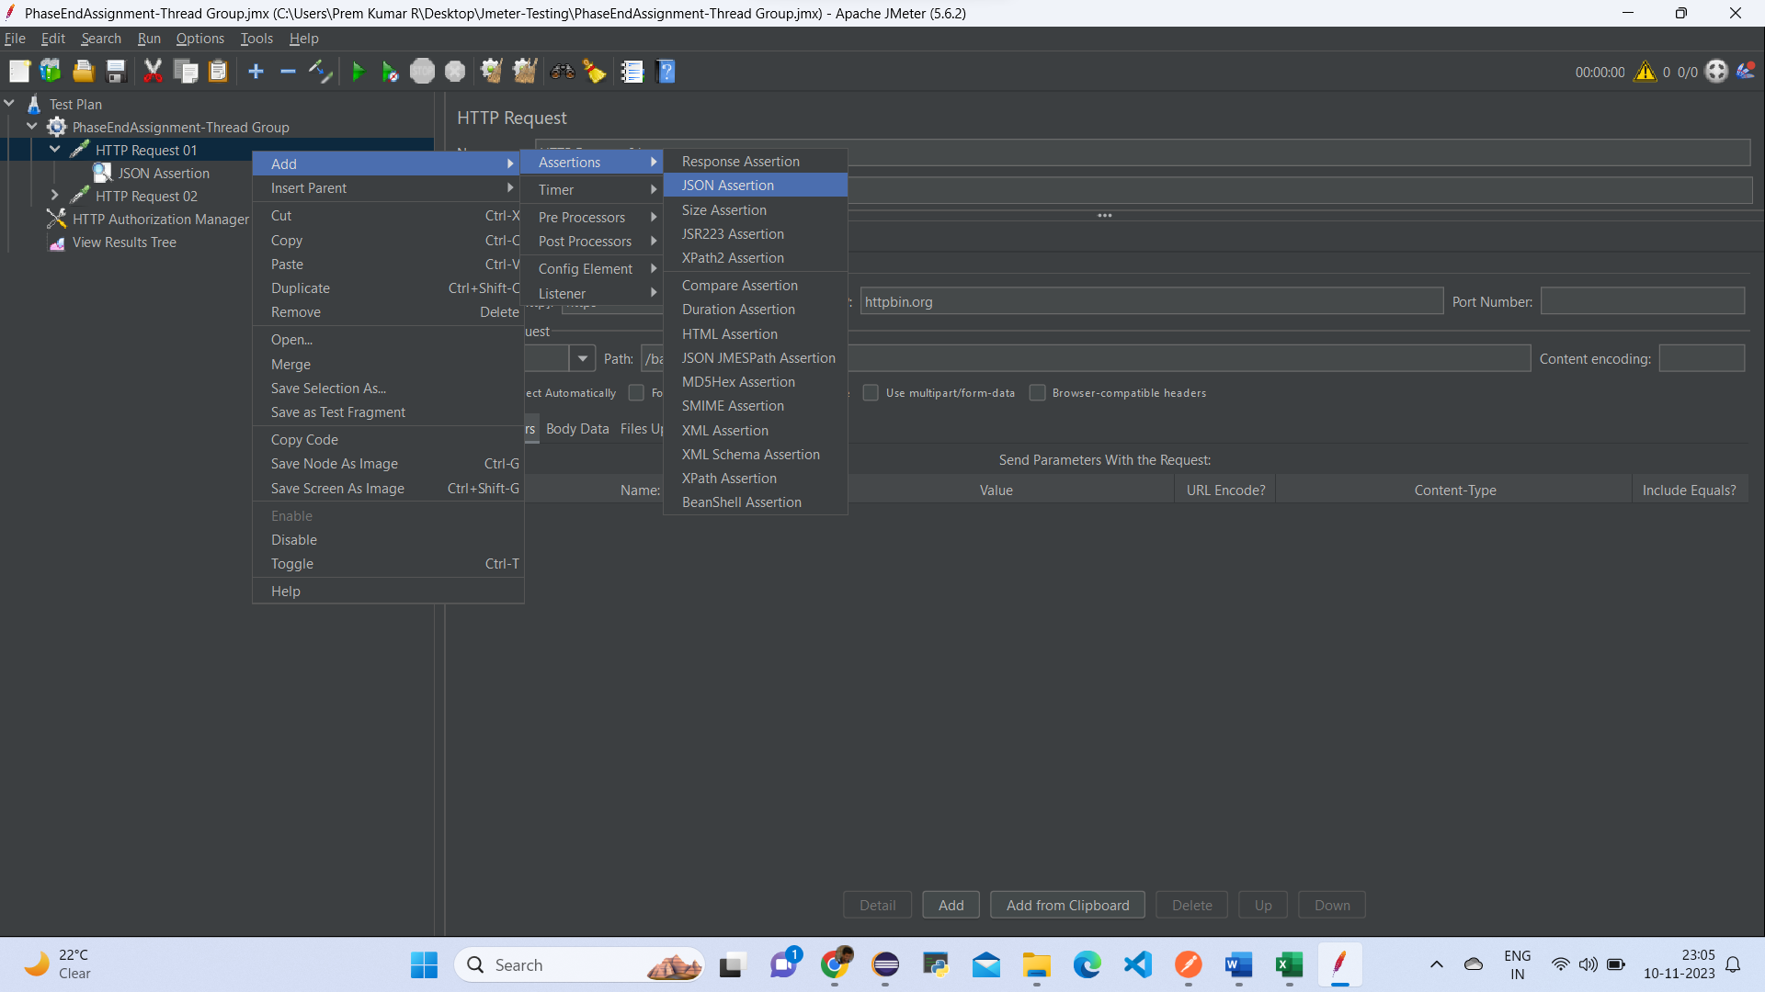

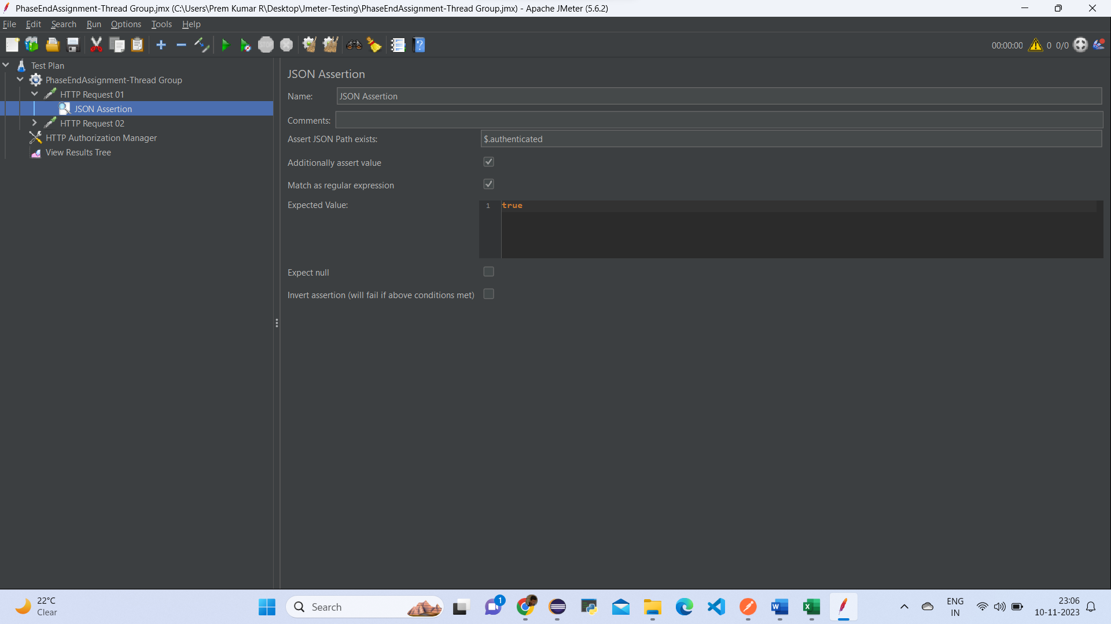

Click on http request🡪Add🡪Assertions🡪XML Assertion

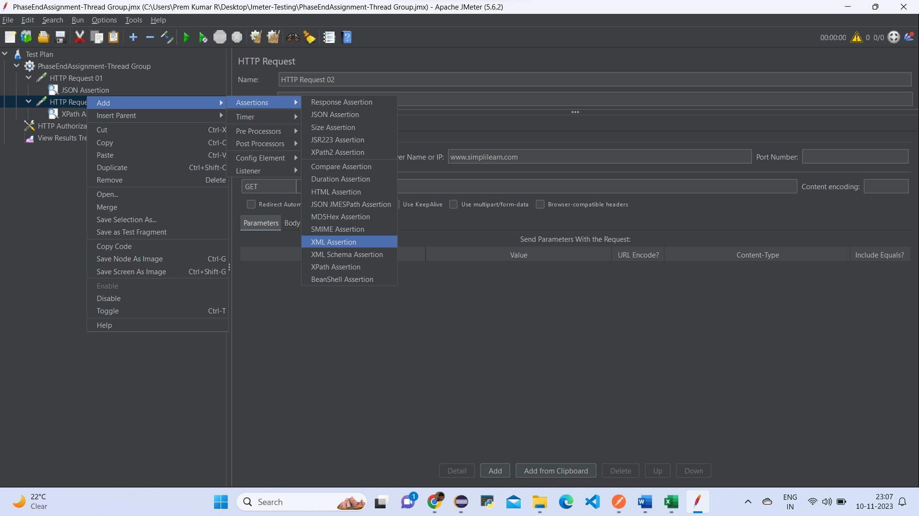

Enable the Use Tidy box

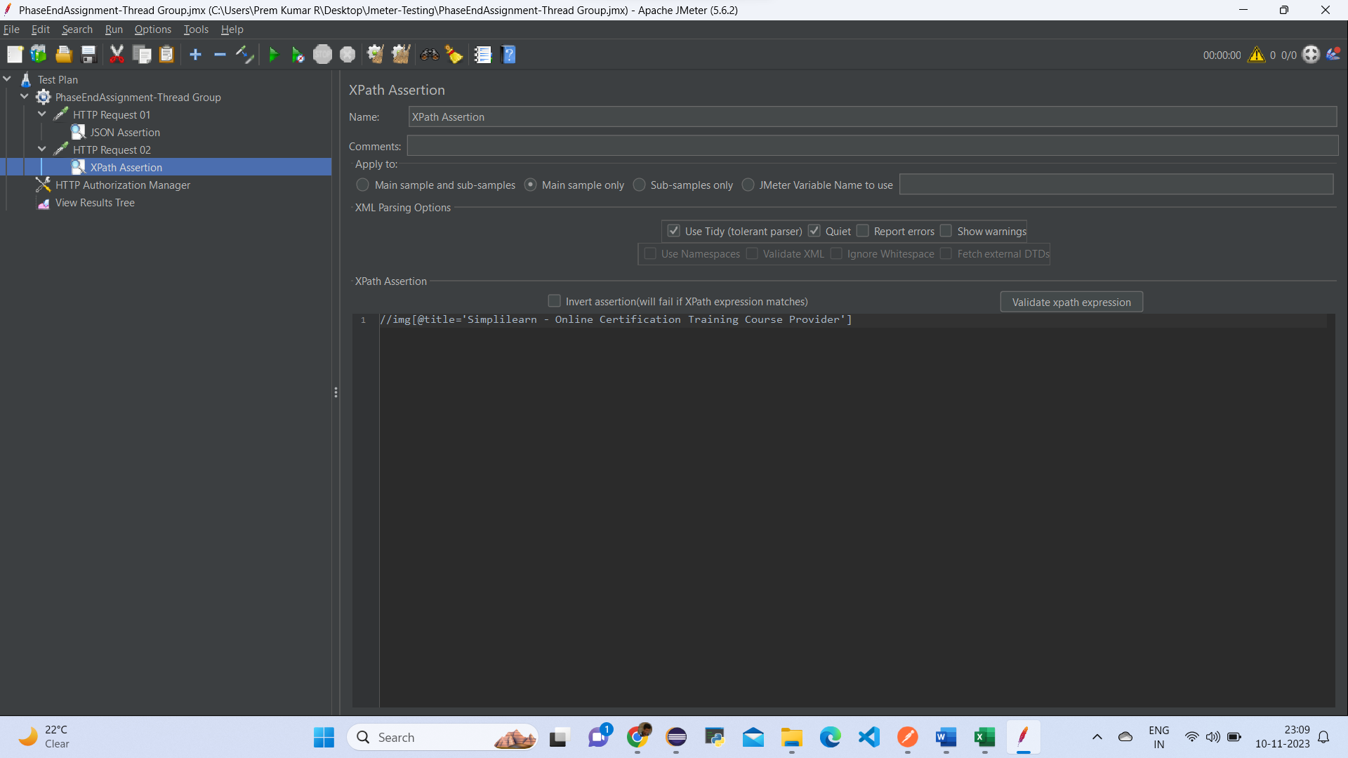

Click on thread group🡪Add🡪Config Element🡪HTTP Authorization Manager

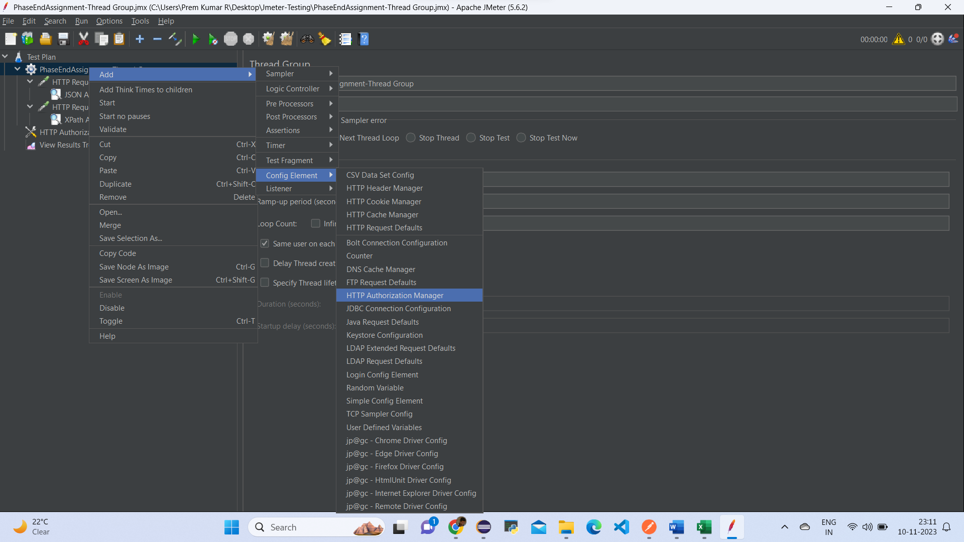

Add the Listener to View the result

